**PYTHON & MACHINE LEARNING**

**BASIC APPLICATIONS**

A CERTIFICATE COURSE CONDUCTED

BY



**THE SURE Trust**

Skill Upgradation for Rural-youth Empowerment – Trust

<https://suretrustforruralyouth.com/>

Course Training Attended

By

CHELIMI NANDINI

MARCH 2023 – JULY 2023



**DECLARATION**

This is to certify that **Ms. CHELIMI NANDINI** has successfully completed the four months training given in “**PYTHON & MACHINE LEARNING BASIC APPLICATIONS**” by SURE Trust during the period from March 2023 to July 2023.

**Mr. Bhargavesh Dakka**

Trainer

Python with Machine Learning

SURE Trust



**Prof.Ch. Radha Kumari Mrs.Vandana Nagesh**

Executive Director & Founder, Director & Co-Founder,

SURE Trust SURE Trust

**TABLE OF CONTENTS**

1.The SURE Trust

2 . Course Content

3. Conduct of the Course

* Student byelaws
* Written Tests
* Assignments

4. Student Feed back

5. Uniqueness of the Course according to student

6. Concluding Remarks

## About the SURE Trust

### Introduction to the SURE Trust

The SURE Trust is born to enhance the employability of educated unemployed rural youth. It is observed that there is a wide gap between the skills acquired by students from the academic institutions and the skills required by the industry to employ them. Employability enhancement is done through giving one on one training in emerging technologies, completely through online mode . The mission of the SURE Trust is to bridge the gap between the skills acquired and the skills required by training them in the most emerging technologies such as Autocad & Solidworks, Python Program, Machine Learning (ML), Deep Learning (DL), Data Science & Data Analytics, Block chain Technology, Robotic Process Automation (RPA), and Project Management and twenty other essential and high in demand Courses ,that will enhance their employability. After completion of four months training in the course, the trainees will get live projects from industries as internship activity to get experience in applying to real time situation what they have learnt during the course. These projects will give them hands on experience which is much sought after by the prospective industry employing them. Currently students from all over India are enrolling for various courses offered by the SURE Trust. The SURE Trust offers every course free of cost with no financial burden of any kind to students. This initiative is purely a service-oriented one aiming to guide the rural youth who are educated but unemployed due to lack of upgradation in their skill sets. The birth of SURE Trust is a God given boon to rural youth who could reach great heights either in employment or in entrepreneurship once they receive the training offered followed by the company internship. Many companies are coming forward to join their hands with us by offering internship projects to hand hold and lead the rural youth in their career settlement.

#### Vision of the SURE Trust

The vision of the SURE Trust is to enhance the employability of educated unemployed youth, particularly living in rural areas, through skill upgradation, with no cost to the students.

#### Mission of the SURE Trust

The mission is to bridge the gap between the skills acquired in the academic institutions and the skills required in industries as a pre-condition for employment.

#### Functioning of the SURE Trust

There are three dedicated, committed, and hard-working women on the board of management of the SURE Trust who will look into the various administrative and other matters relating to the enrolment of students, organizing trainers, entering into agreements with companies for getting live projects to students as internship programs, and so on.

All the three women on the board are all the alumni from Sri Sathya Sai Institute of Higher Learning, Anantapur Campus, deemed to be a University. The women board is supported by five eminent advisories who are from different walks of life and have made outstanding mark in career in their respective fields. For more details about SURE Trust please visit the website [www.suretrustforruralyouth.com](http://www.suretrustforruralyouth.com/).

2. Course Content

The SURE Trust conducts a five months training for every course on a uniform basis. A session spanning across one to one & half hour is taken by the trainers for every major course. Sessions are conducted to complete the predesigned course structure within the fixed time period. Course content is designed to suit the current requirement of the Industry and validated by the industry experts. The course content of all these courses is so dynamic that any changed condition noticed in the industry will automatically get reflected in the content of the respective course . As the course content is dynamic, the Following is the course content of the current course in Data Science and Data Analytics:

## PYTHON & MACHINE LEARNING BASIC APPLICATIONS

**Objective:**

The objective of this course is to train the learners to program in Python, analyzing and visualizing data, developing & evaluating models; and get introduced to complex computations.students in the basic to design python software.

**Course content:**

**Module 1.** **Python for data science and machine learning**:

* Python basics
* Python OOPs

**Module 2.** **Data analysis:**

* Pandas library
* Numpy library

**Module 3.** **Data visualization:**

* Matplotlib
* Seaborn

**Module 4.** **Exploratory data analysis:**

* Univariate
* Bivariate
* Derived metrics
* Introduction to databases (MySQL for Data science students)

**Module 5.** **Math for machine learning:**

* Statistics
* Linear algebra
* Calculus
* Probability theory

**Module 6.** **Supervised learning:**

* Feature selection
* Regression
* Linear regression
* Polynomial regression
* Advanced regression introduction
* Classification
* Logistic regression
* Naive Bayes
* Support vector machine
* Tree models

**Module 7.** **Advanced regression:**

* Regularized regression
* Ridge and Lasso regression
* Model selection and Grid Search methods

**Module 8.** **Unsupervised learning:**

* K means clustering
* Hierarchical clustering
* Principal component analysis

**Module 9.** **Theory introduction to deep learning and reinforcement learning :**

* Theory about ANN, CNN, RNN, LSTM
* Theory about Markov Decision process

## 3.Conduct of the course

1. Modalities for the conduct of all the courses are fixed by the SURE Trust which are uniformly followed across the courses.
   * Mode of Training --- Online
   * Period of Training --- Four months
   * Sessions per week --- 5 to 6
   * Length of the session --- 1 to 2 hours
   * Tests to be taken --- 2 per month
   * Assignments --- 1 per day
   * Last 15 days --- Final practice and preparing the course report
2. Student byelaws:

* Students enrolling for the courses under SURE Trust are strictly required to follow the following byelaws set for them.

**Byelaws for students to become eligible for certificate at the end of the course**

1. Minimum Attendance:

* Every student must put in a minimum of 85% attendance in attending the classes for getting the eligibility to receive the certificates.

1. Two written tests are to be taken in each month:

Since the objective of the certification program is to turn out well qualified students from the respective courses,minimum two written tests are to be taken in each month for each course to ensure that the students are pulled along the expected line of standard.

1. Assignment submissions:

Ten exercises constituting one assignment for every two to three new functions/topics taught, resulting in minimum seven such assignments are to be submitted during the four months period.

1. Preparing the final course report in the prescribed format:

During the last fifteen days in the fourth month, students many be asked to consolidate and compile all the assignments submitted in a word document along with the other chapters which will constitute a course report for each student. This report will be the unique contribution a student carries from the trust to show case the rigorous training he/she received during the four months period. Besides the report will stand as a testimony for the detailed learning a student has acquired in the chosen area. This will facilitate the industry in handpicking the required student for the job.

1. External Viva-vioce:

Every student has to successfully clear the external viva-voce arranged in their respective course.

1. KYC norms:

Each student wishing to enroll for the course must submit a written letter saying that he/she will not drop from the course until its completion, which will also be signed by father / mother besides the student himself / herself.

1. Attend the full class:

All the students are expected to attend each class for full duration. Some students are observed moving out of classes after logging in which does not go well with the learning objective of students.

1. Ensure discipline in the group:

All the students are advised strictly to follow group etiquette and restrain from posting in the group any unethical messages or teasing messages or personal interactive messages. This group is purely created for academic purpose and hence only academic interactions should go on.

**Python & Machine Learning Basic Applications**

* The course is taught to the students as per the syllabus prescribed and as per the course modalities keeping in mind the bylaws set for them.
* Periodical tests are conducted to assess the understanding of the students in the course.
* Assignments are given to ensure that students gain versality in the designing.
* The assignments of the student are given below. These assignments which are done with high creativity and out of box thinking not only reflect the student’s innovativeness but also constitute solved exercises in the Various designs for the fresh learners to practice and gain confidence.
* The assignments are listed below in the order of their conducting during the course.

**Assingment 1 :**

1.Write a program to accept percentage from the User and display according

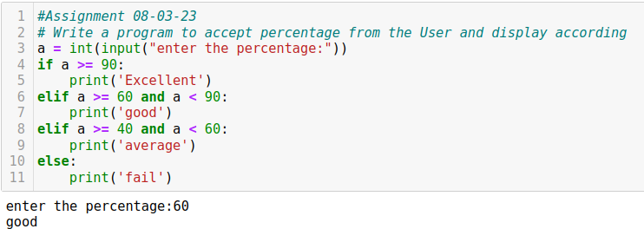

**Assingment 2 :**

Calculate Principle, Tenure and Rate of Interest

Output should be calculated of Simple interest by using user input format

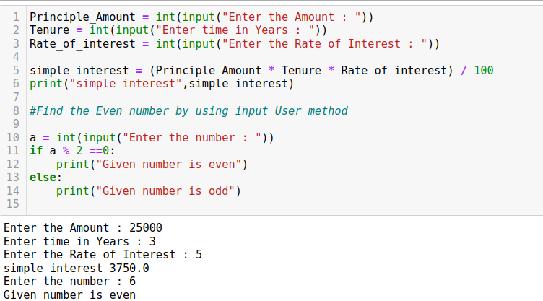

**Assingment 3 :**

# **print the Message**

Calculater :

1. Add

2. Subtract

3. Multiply

4. Divide

#input

Enter Choice (1-4) : 3 Enter A:10 Enter B:20

# output

product = 200 by using input Format

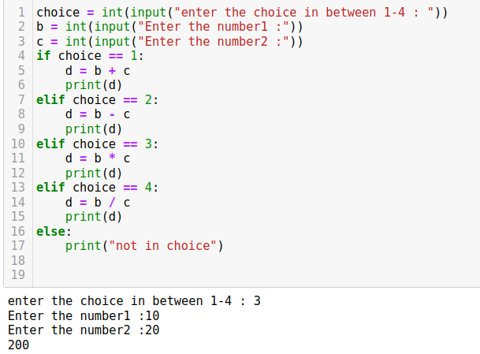**Assingment 4 :**

Create a Vault by using input user method

# Input

Enter a String = xyz Enter a String – xyz123

Output

Either it could be 1.Successfully logged in!!! 2.Please Check your userid Or Password Use by if and Else Statement

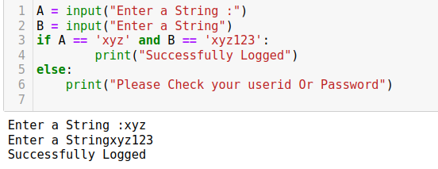

**Assingment 5 :**

# Assignment 13-03-22

WAP Currency Converter should be able to convert a Specific Currency

# Inputs :

USD (U.S.Dollars)(1 USD = 82.16 INR)

YEN (japanese YEN)(1 YEN = 0.62 INR)

EURO (1 EURO = 88.04 INR

U.K. POUND(1 U.K.Pound = 99.86 INR)

Enter the currency which you want to convert- eg USD-EURO Enter the value of the currency you want to convert 5000

the converted value-

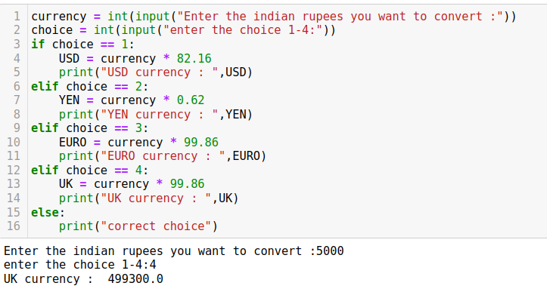

**Assignment 6 :**

Accept the three numbers form the user and display the Second largest number

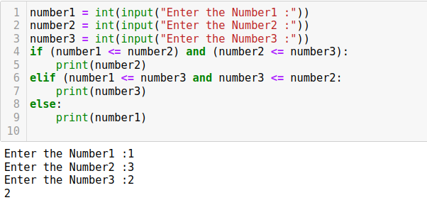

**Assignment 7 :**

Write a Python program to check if a triangle is a equilateral,isosceles or Scalene

An equilateral triangle is a triangle in which all three sides are equal An scalenev triangle is a triangle in which all three sides are unequal An isosceles triangle is a triangle in which any two sides are equal

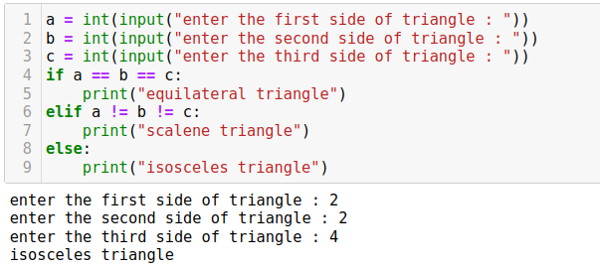

**Assignment 8 :**

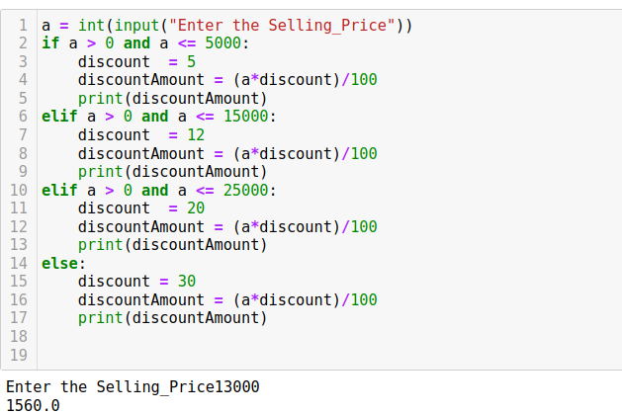Enter the Selling Price and caluculate discount based on the range of Selling Price The discount rate is: a)5% if Selling Price is atmost 5000. b)12% if Selling Price is atmost 15000. c)20% if Selling Price is atmost 25000. d)30% if Selling Price is atmost 25000.

**Assignment 9 :**

Write a Python programe to convert a month name to a number of days.Expected Output: List of months:January,February,March,April,May,June,August,September,October,November,December Input the name of Month:February no of days:28/29 days.

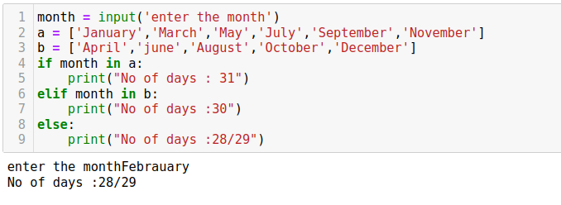

**Assignment 10 :**

Print a number pattern using a for loop and range function:

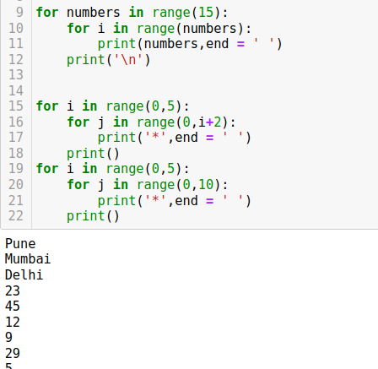



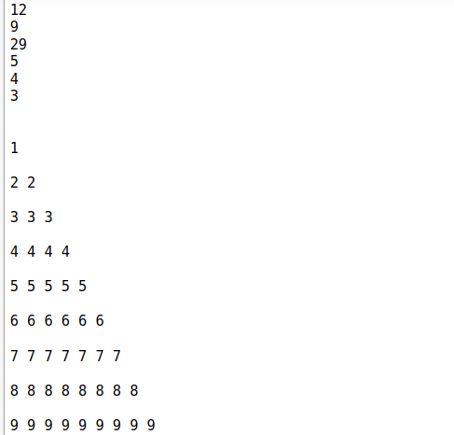

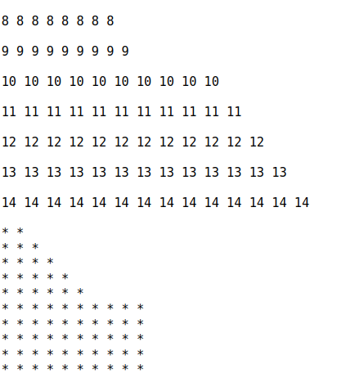

**Assignment 11 :**

if is used for comparison and for is used for you are analyzing house prices.The qiven code declare a list with house price in the heighborhood.you need to calculate and output the number of houses thst have a price that is above the average.

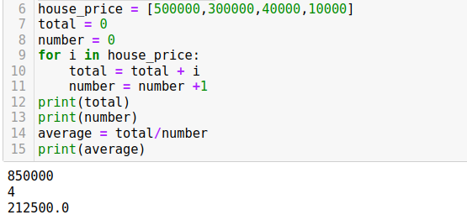

**Assignment 12 :**

if we have a ticket number and age

write a program to bulid if age is greater than 18 then ticket cost is 20 otherwise 5

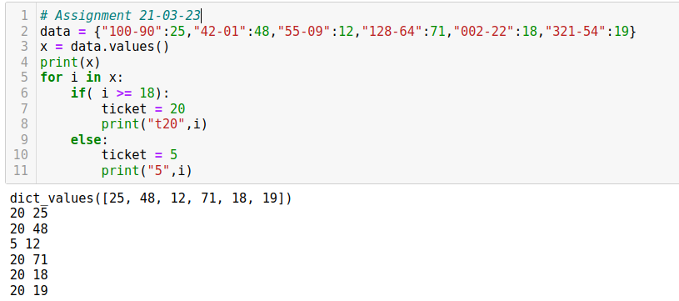

**Assignment 13 :**

write the combination of if and else statement The statement search for prime numbers

from 10 through Break condition

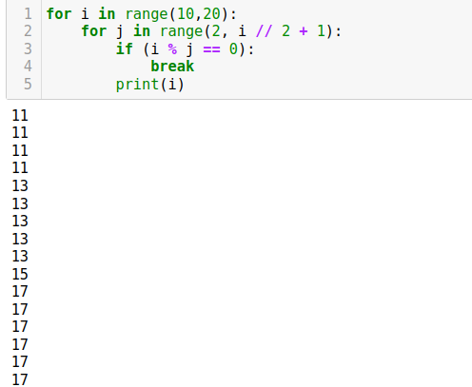

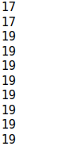

**Assignment 14 :**

print the table of number for 13 to 17 by list comprehension

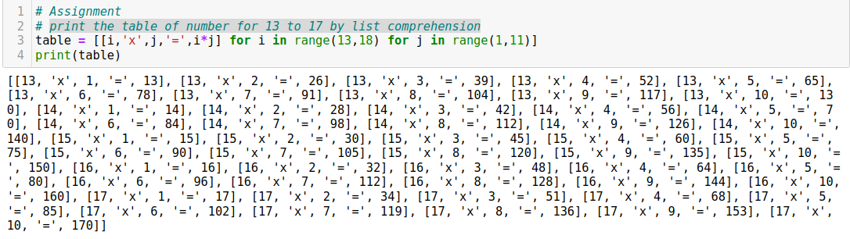**Project 1 :**

1.find all of the numbers from 1-1000 that are divisible by 7

2.find all the numbers from 1-1000 that have a 3 in them

3.count the number of spaces in a string

4.Create a list of all consonants in the string "Yellow Yaks like Yelling and yawning and yesturday they yodled while eating yuky yams"

5.Get the index and the values as a tuple for items in the list "hi",4,8.99,'apple',(t,b,n).result would look like(index,value)

6. Get only the numbers in a sentence like 'in 1984 there were 13 instances of a protest with over 1000 people attending'

7.Given numbers = range(20),products a list containing the word 'even' if a number in the number is even,and the word 'odd' if the number is odd.Result would look like 'odd','odd','even'

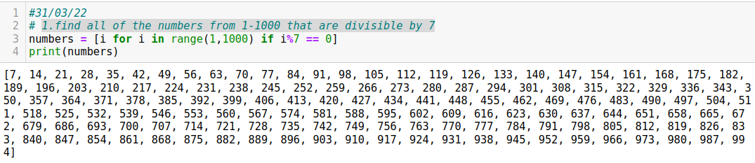

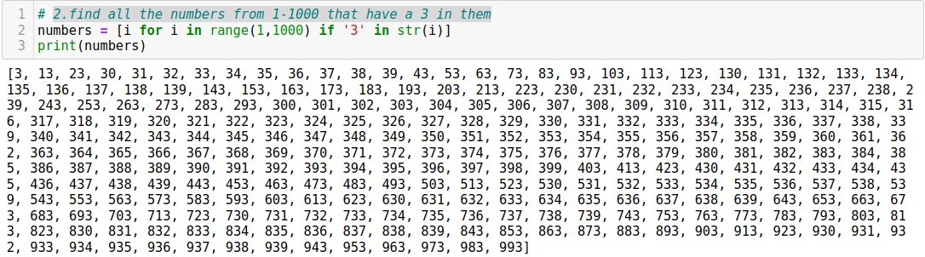

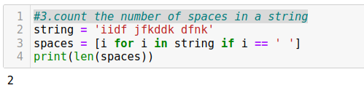

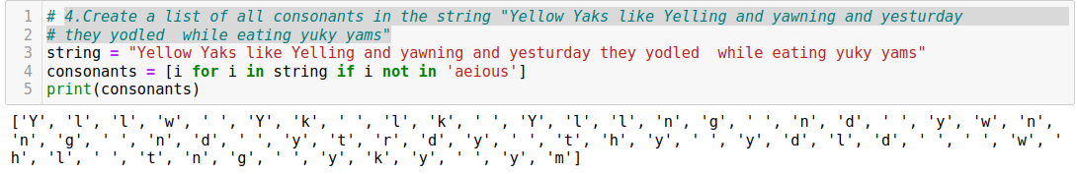

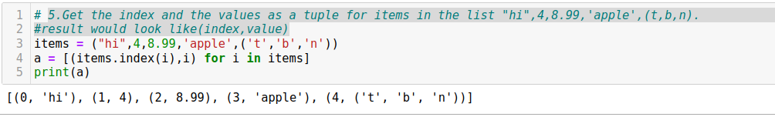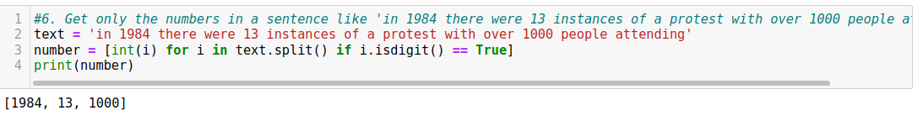

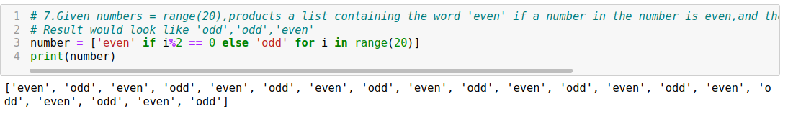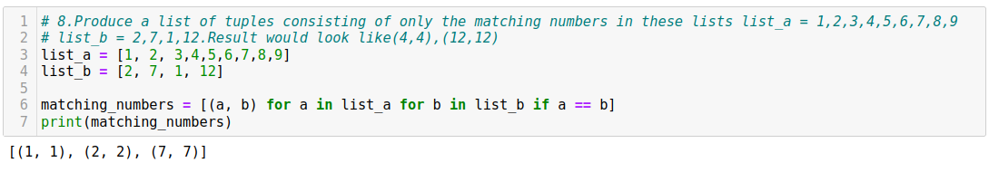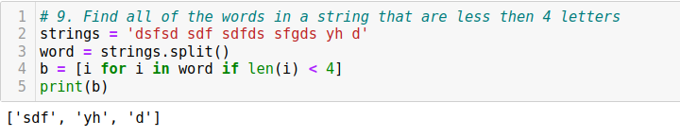

**Assignment 15 :**

1.Have to take only even numbers from the key_value pairs

2.Have to take the values which are not even and lesser than 40

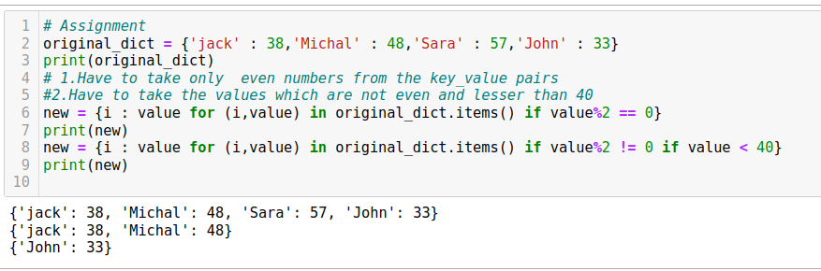

**Assignment 16:**

# Find the largest number inside the list without using sort function

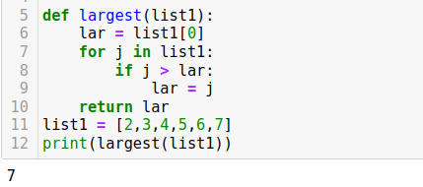

**Assignment 17:**

find life excectancy calculater

def new_life(name,age): ["jane",'Zack','Melissa']

smoker age 40 non smoker age 70

life remaining = life_exp - age

output: hii Jane! your life expectancy:-----years

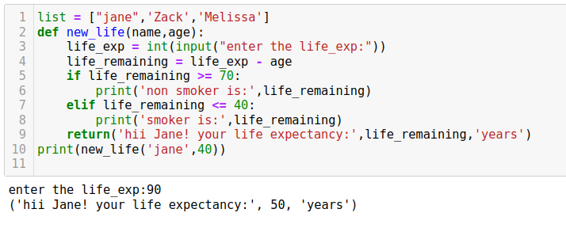

**Assignment 18:**

1.#Write a python program to sort a list of tuple using lambda

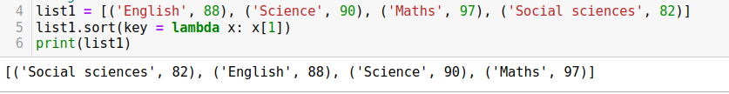

2.write a python programe to find whether a given string starts with a given character #using lambda

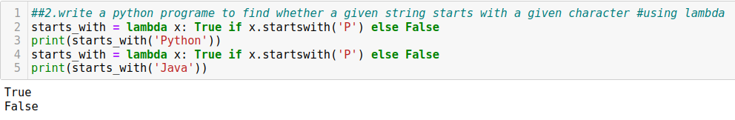

**NUMPY :**

**Assignment 1:**

write a numpy program to create a 2D array with 1 on the border and 0 inside

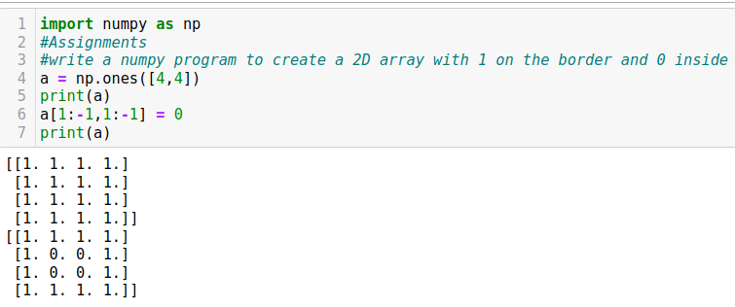

**Assignment 2:**

1.Write a numpy program to create a vector with value ranging from 15 to 55 and print all values except the first and last.

2.Write a numpy program to create a vector of length 5 filled with arbitrary integers from 0 to 10

3.Write a numpy program to create a 3 x 4 matrix filled with values 10 to 21

4.write a numpy program to create a 3 x 3 x 3 array filled with arbitrary values

5.write a numpy program to compute the inner product of two given vectors

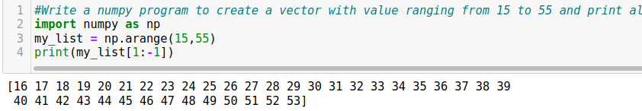

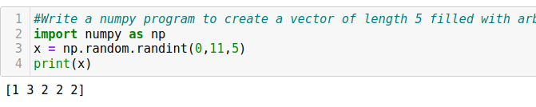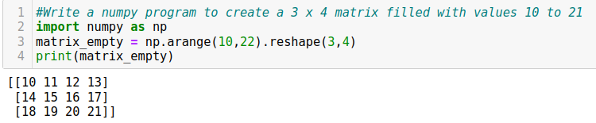

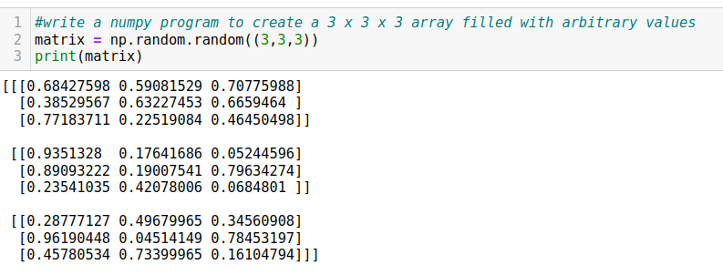

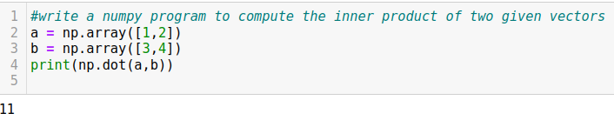

**Assignment 3:**

Given a 2D binary matrix A of dimensions NXM,determine the row that contains a minimum number of 1's note-The matrix contains only 1s and 0s.Also,if two or more rows contain the minimum number of 1's, the answer is the lowest of those indices input: n=4,m=5 A=[[1,1,1,1],[1,1,0,0],[0,0,1,1],[1,1,1,1]] output: 2 Explanation: Rows 2 and 3 contain the minimum numberof 1's(2 each).Since,2 is less than 3. thus the answer is 2. your Task: you donot need to read input or print anything.your task is to complete the function minrow() which takes the two integers N,M as well as the 2D matrix as input parameter and returns the minimum index of the row which contains the least number of 1's

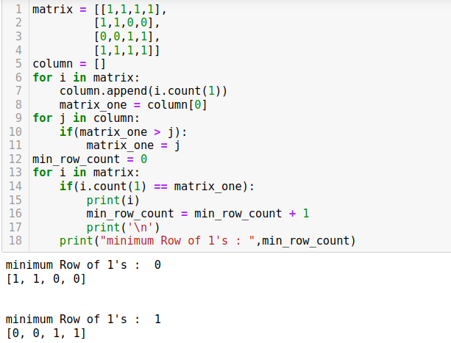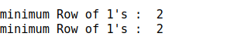

**Assignment 4:**

Given an array of size N-1 such that it only contains distinct integers in the range of 1 to N

find the missing elements

input:

n=5

a[]={1,2,3,5}

output:4

your task:

you donot need to read the input or print anything.

complete the function MissingNumber() that takes array and N as input parameters and returns the value of the missing number

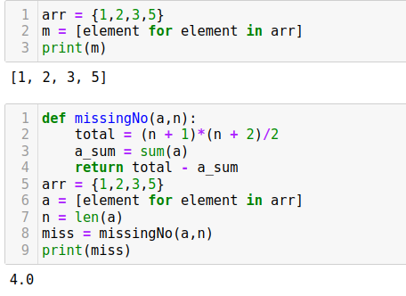

**Assignment 5 :**

Given an array arr[] of N+2 elements. all elements of the array are in the range of 1 to N.

And all elements occur once except two numbers occur twice.find the two repeating numbers.

input: arr = [4,2,4,5,2,3,1],N=5

output:4 2

Explanation: The above array has n + 2 =7 elements with all elements occuring once except 2 and 4 which occur twice.So the output should be 4 2

input arr =[2,1,2,1,3],N=3

output:1 2

Explanation:The above array has n + 2 = 5 elements with all elements occuring once except1 and 2 which occur twise.so output should be 1 2.

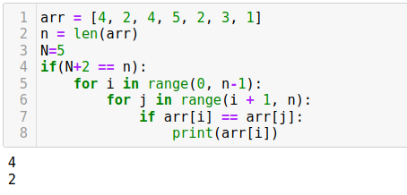

**Assignment 6 :**

Given two sorted arrays may have some commom elements.Find the sum of the maximum sum path to reach from the beginning of any array to the end of any of the two arrays.we can switch from one array to another array only at common elements

note: The common elements do not have to be at the same indexes. input: ar1 = {2,3,7,10,12}, ar2 = {1,5,7,8} output: 35.

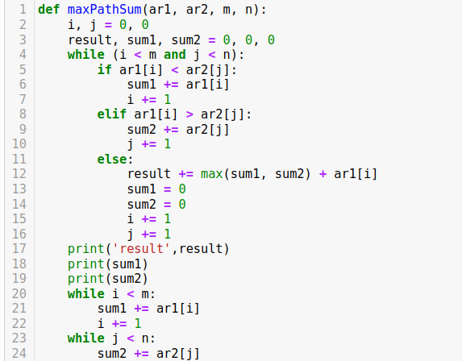

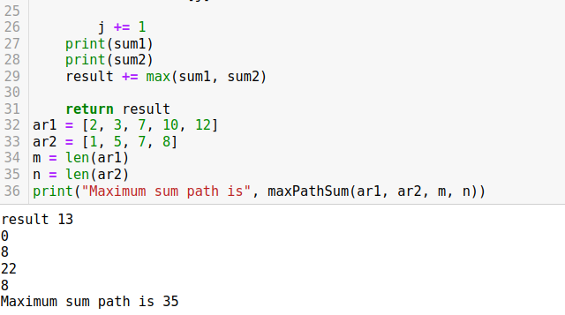

**Pandas:**

**Assignment 1:**

Given an array of non-negative integers and an integers and an integer sum,find a subarray that adds to a given sum

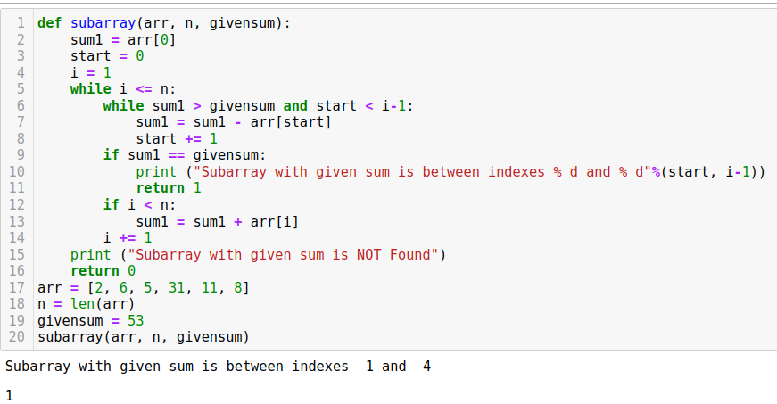

**Assignment 2:**

1.create a series by using dictionary and filter out number which is greater than 3

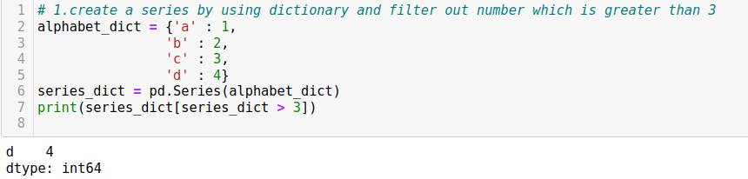

2.Create a series by using numpy array from the range 1 to 100 filter out all the number from 95 to 100

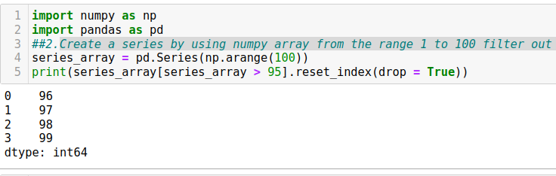

**Assignment 3:**

Write a python program to find palindromes in a given list of strings using lambda. Original list of strings: ['php','w3r','python','abcd','java','aaa'] List of pallindromes: ['php','aaa']

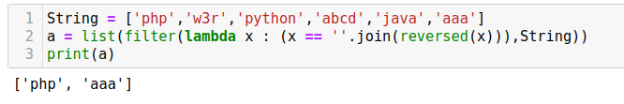

**Assignment 4:**

Create a DataFrame with Index

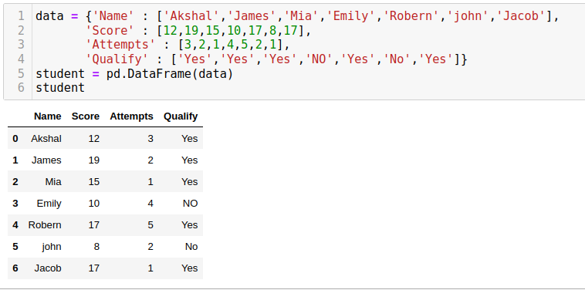

**Assignment 5:**

Customer id,Age,Gender,Salary,City_Residence custermer_data_1

Create an another sheet with same custermer_data_2 and concate them

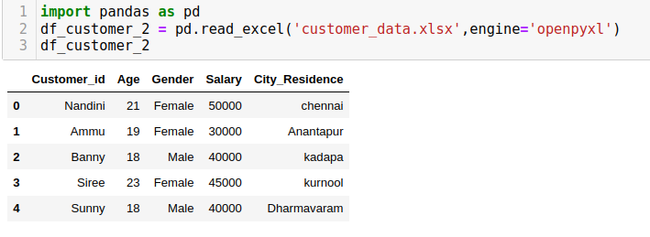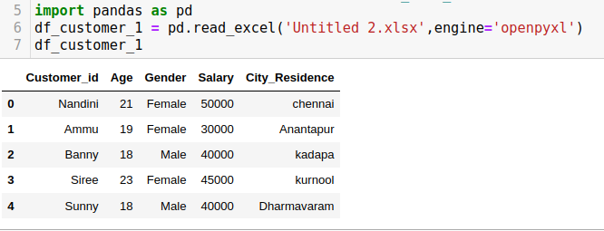

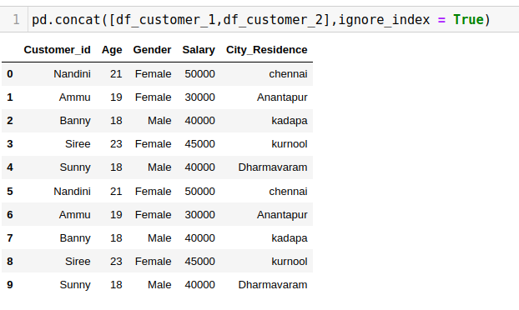

**Assignment 7:**

Find city-wise distibution of salary for different genders in empolye dataset

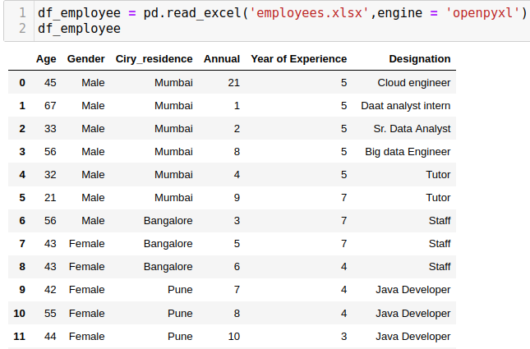

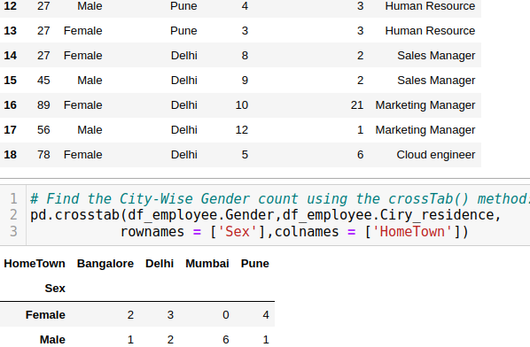

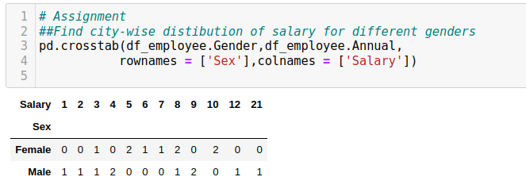

**Assignment 8:**

Give employee id 10 and then salary and year of joining and age

do multiple line plots

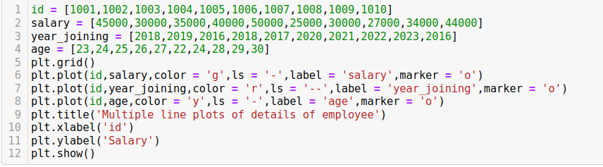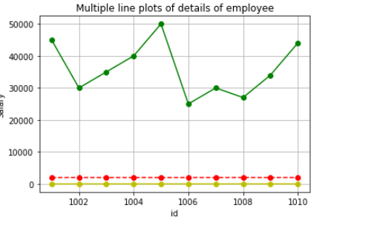

**Project 2:**

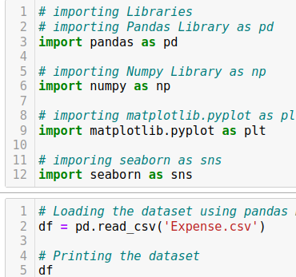

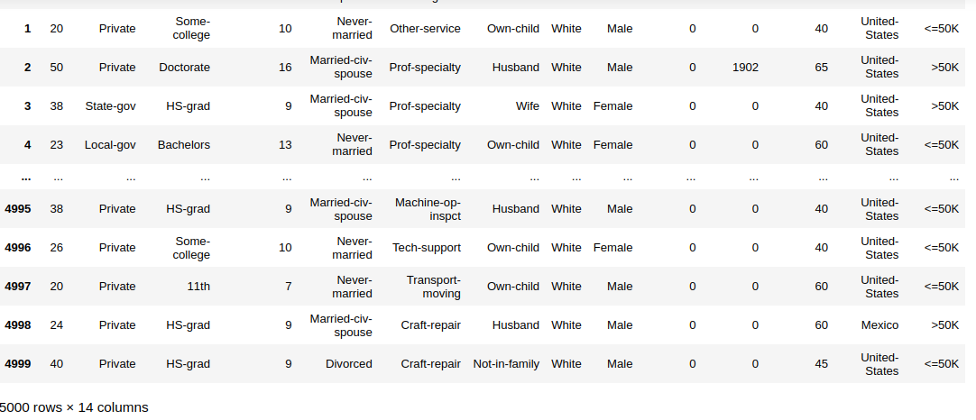

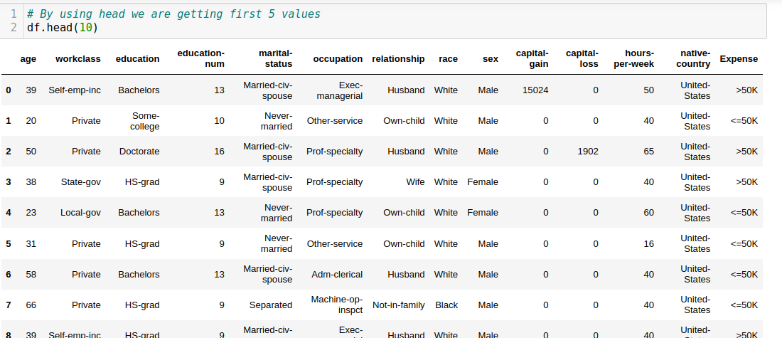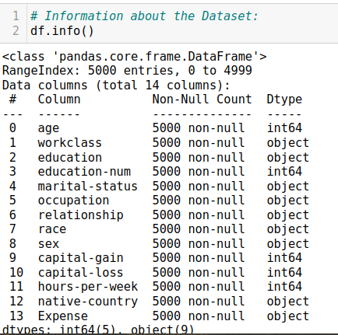

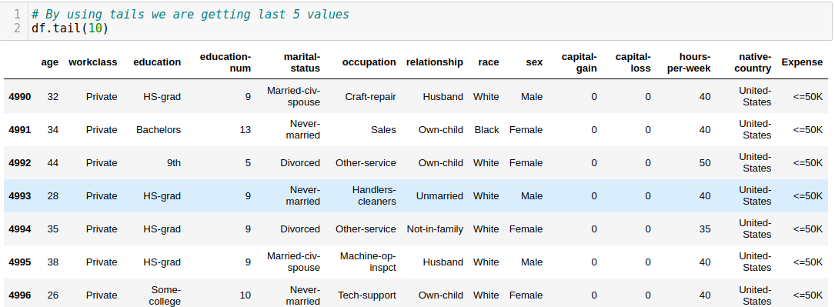

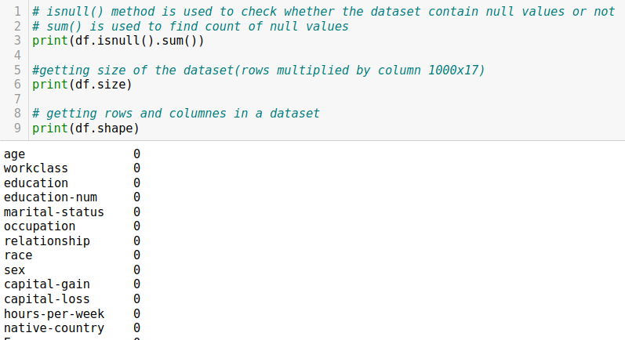

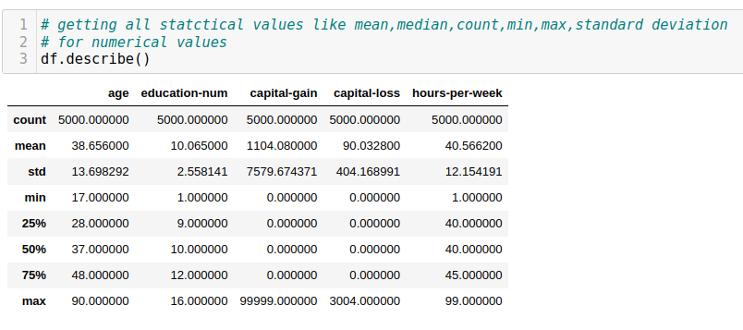

### DATA VISUALISATION

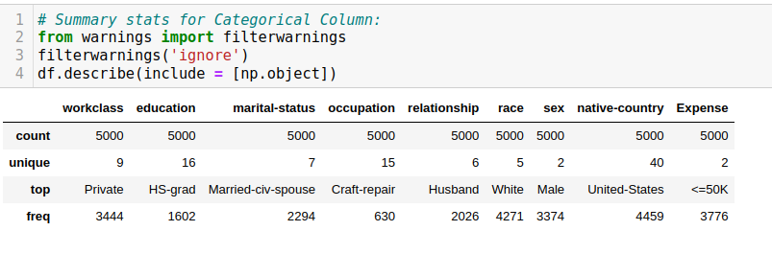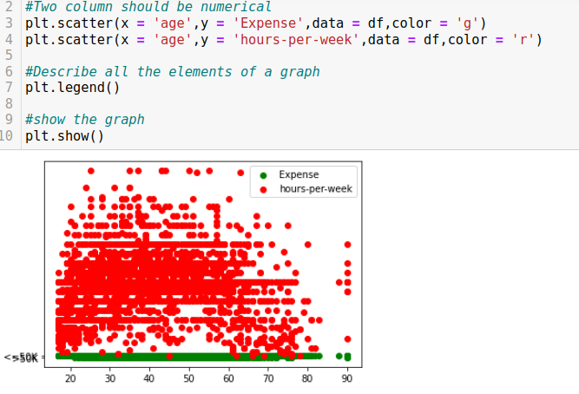

### 

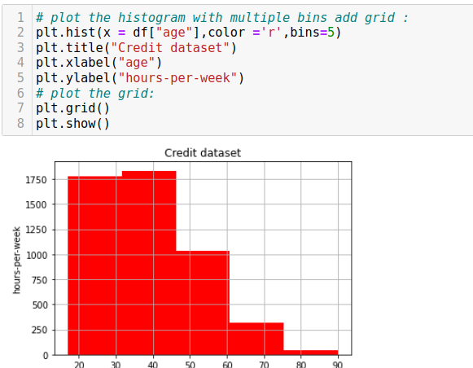

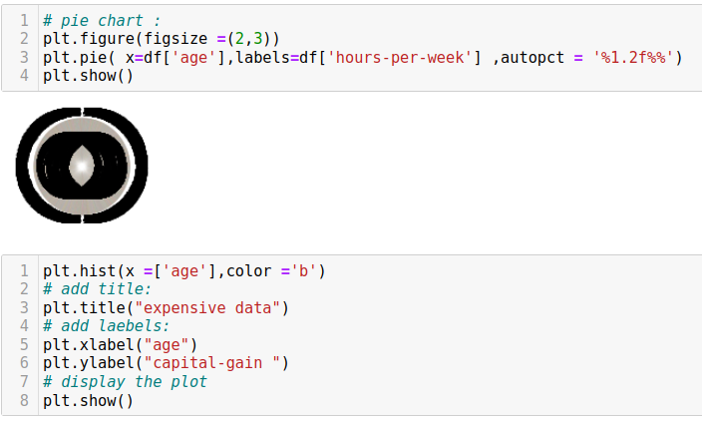

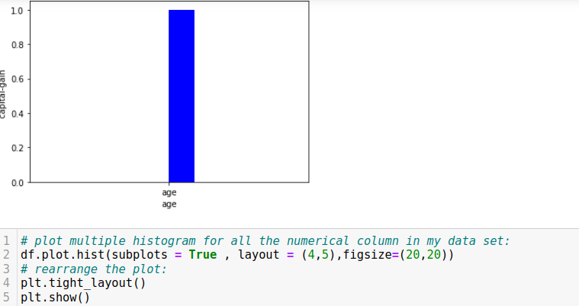

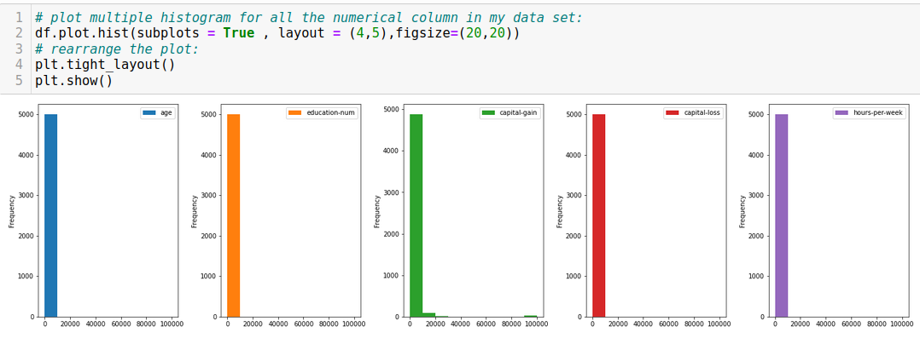

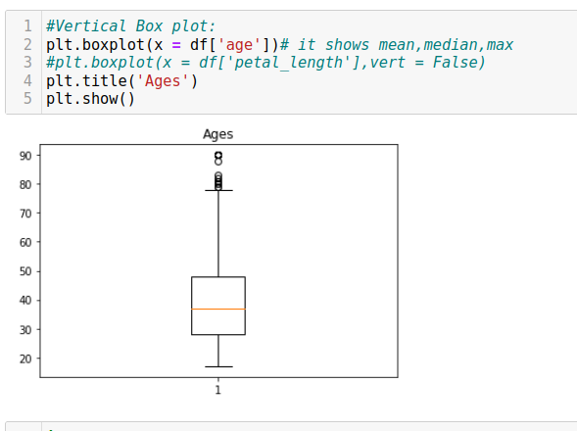

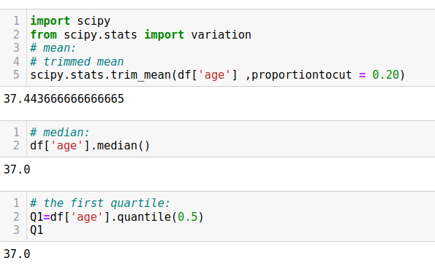

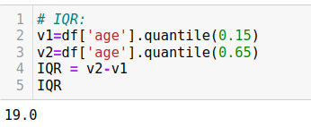

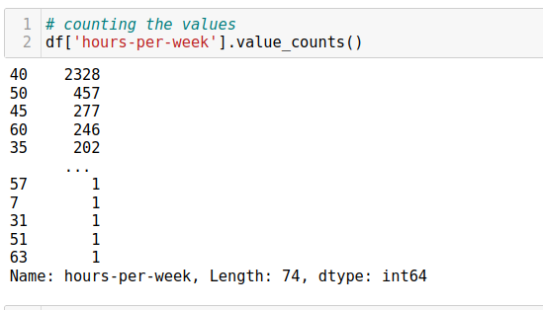

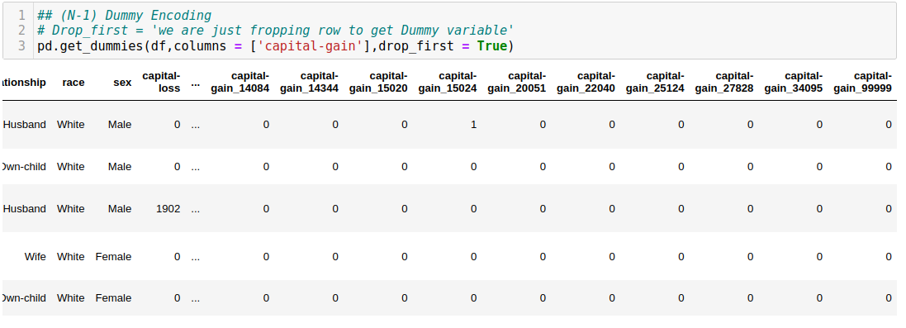

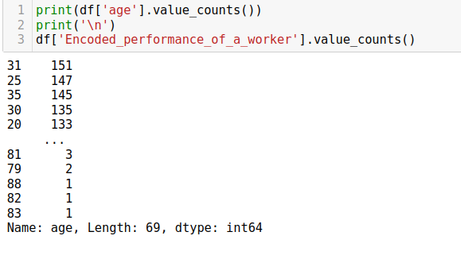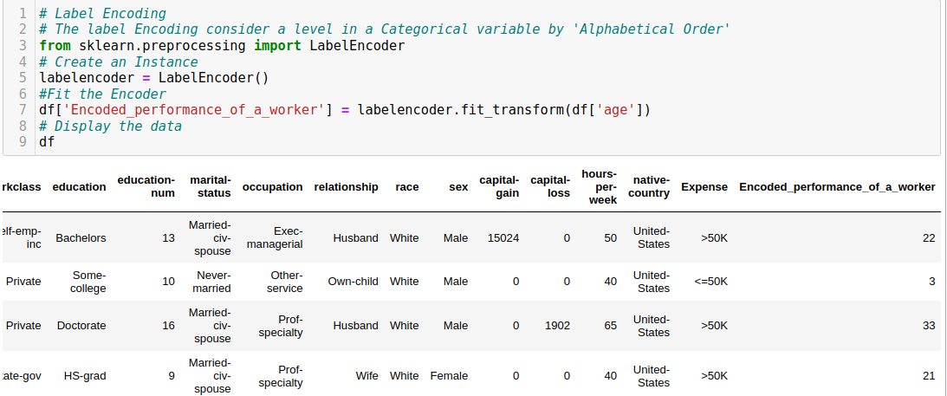

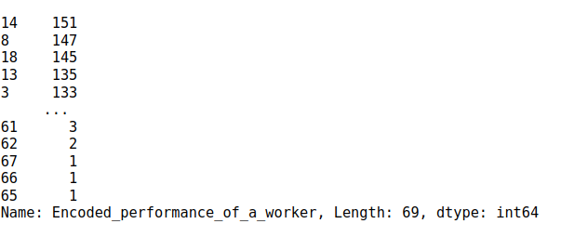

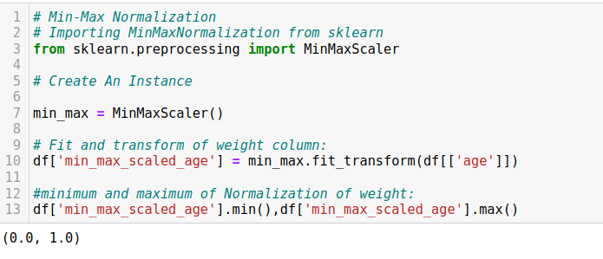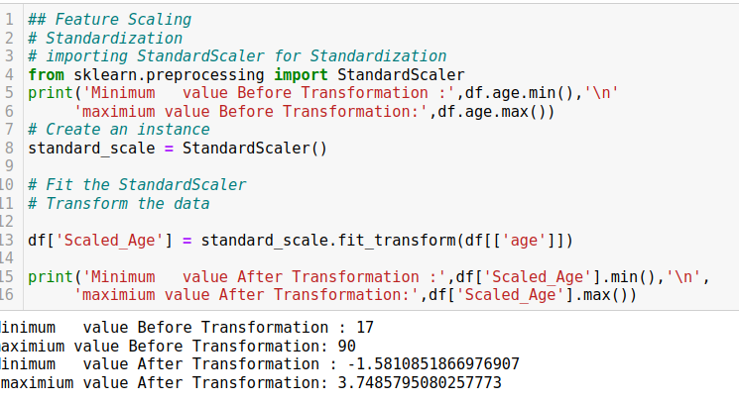

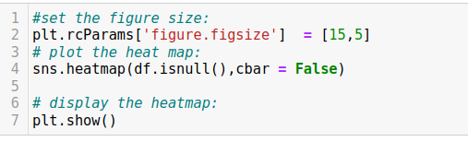

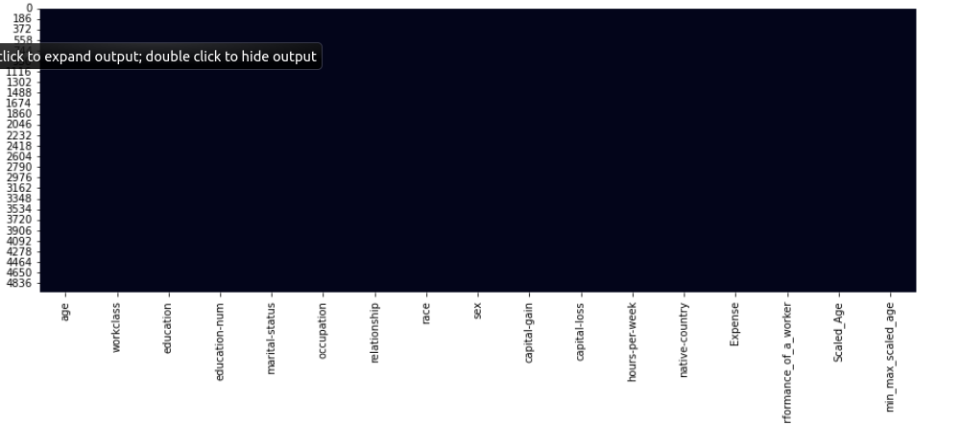

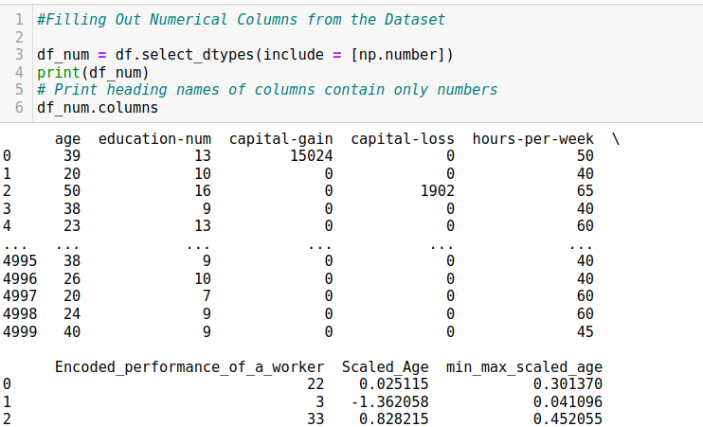

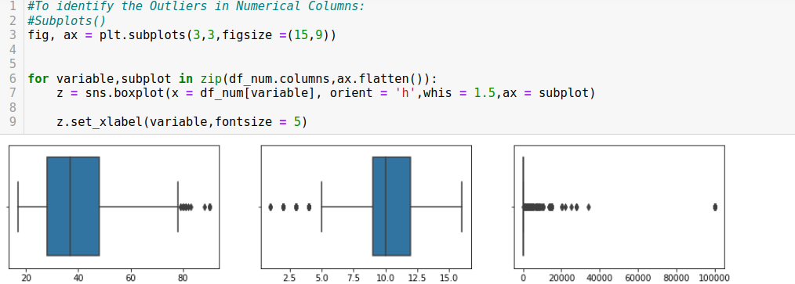

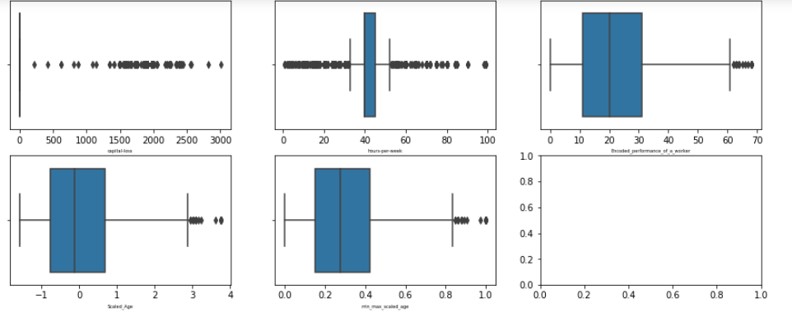

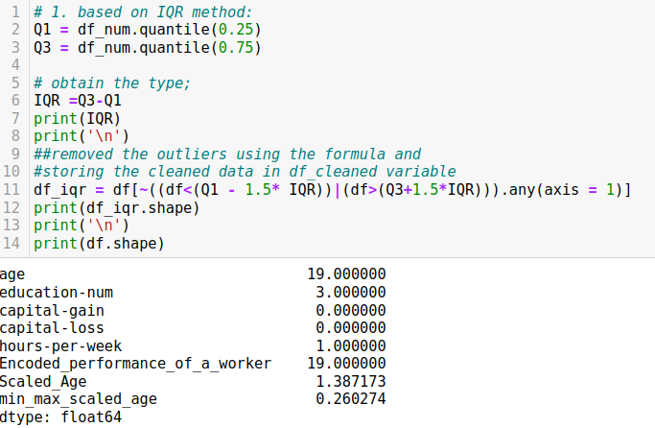

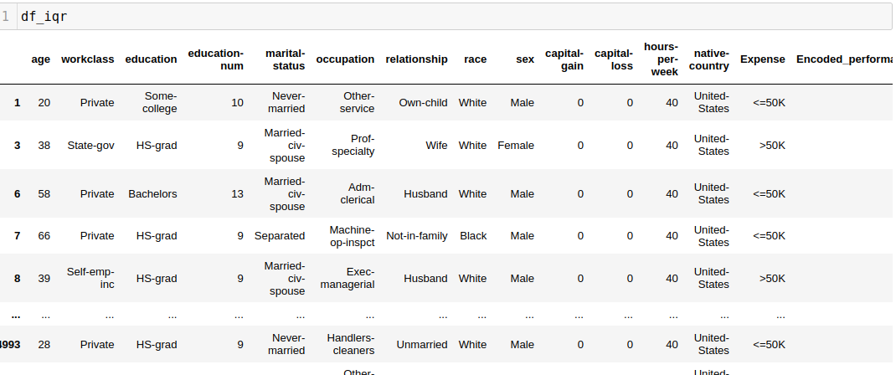

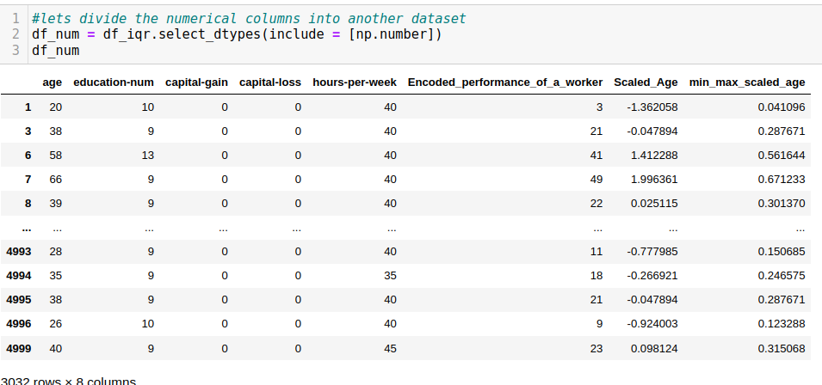

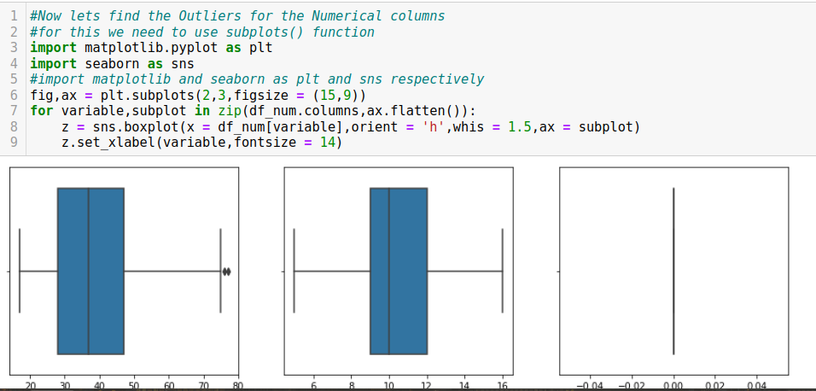

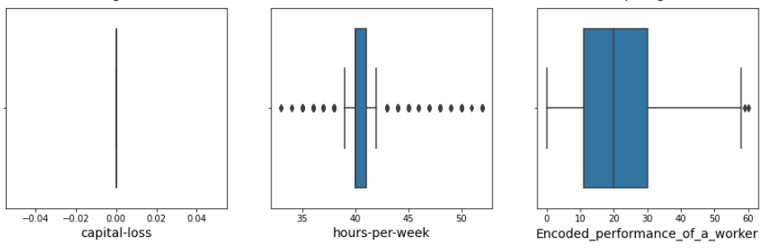

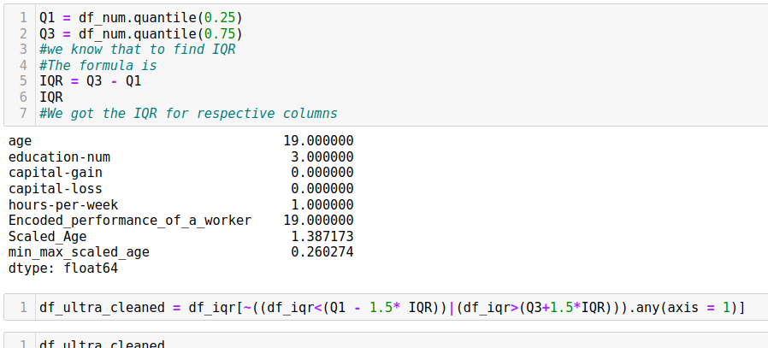

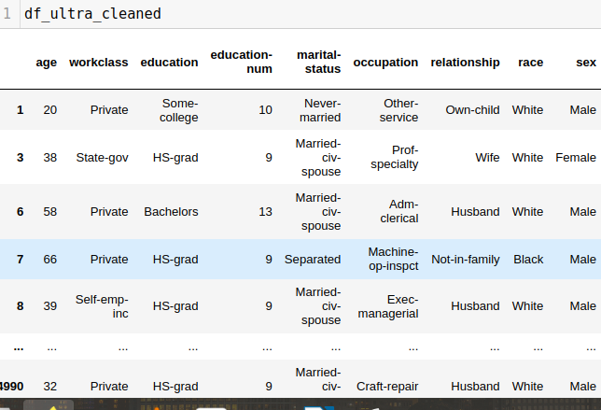

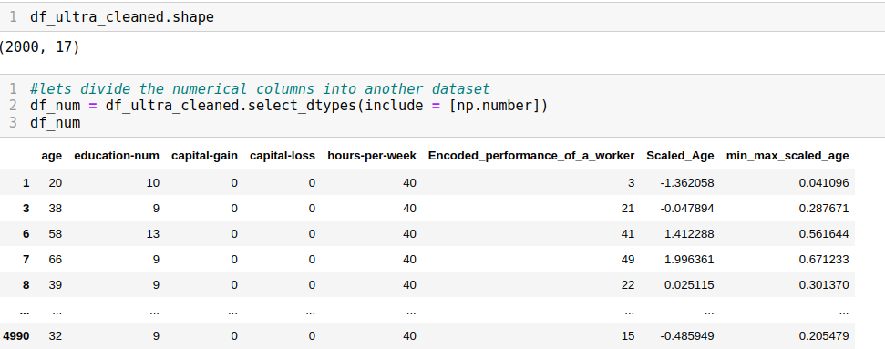

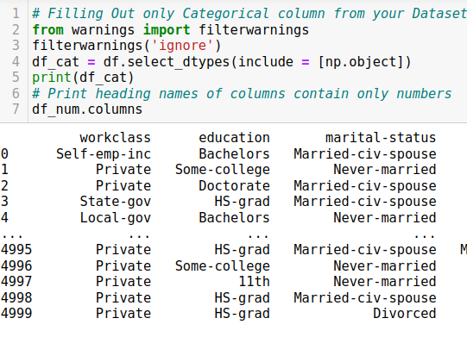

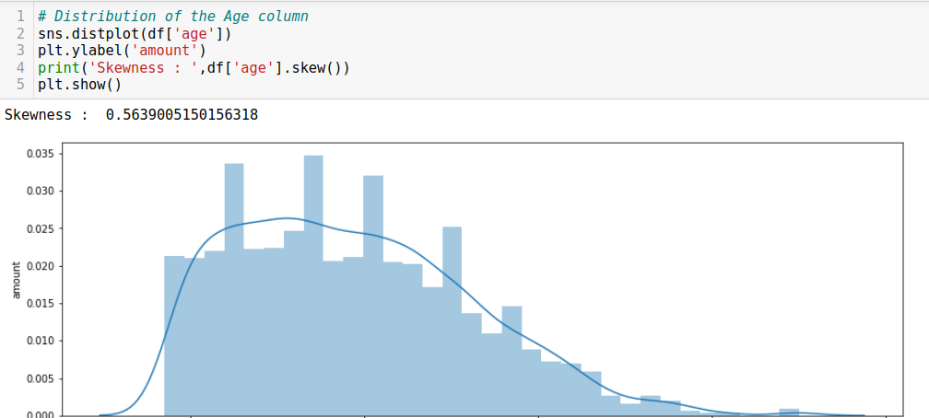

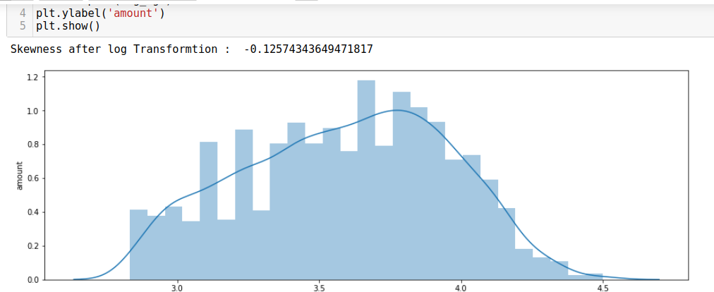

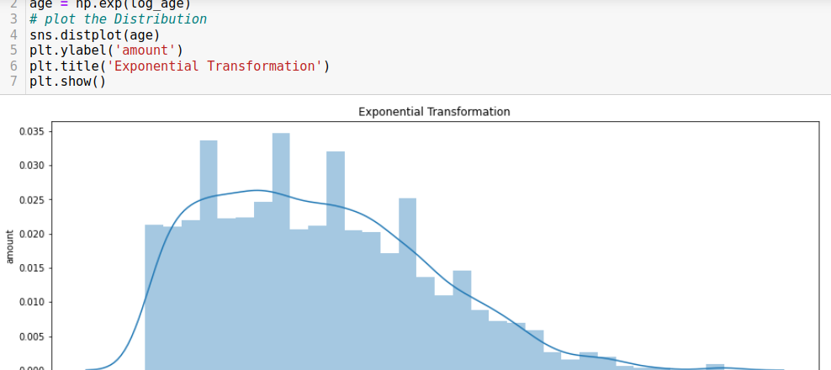

**Project 3:**

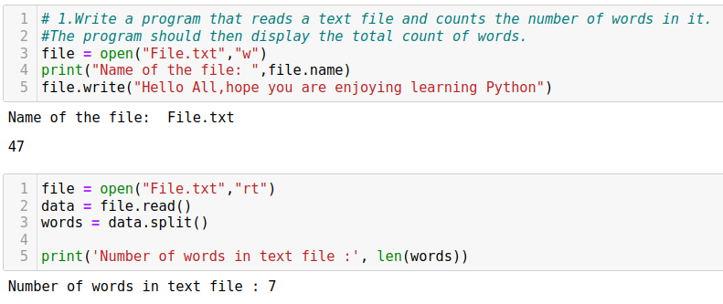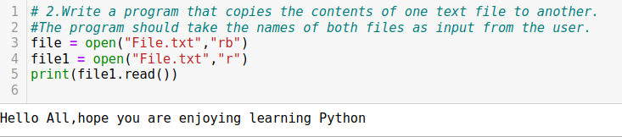

3.Write a program that encrypts a text file. The program should read the contents

of the file, apply a simple encryption algorithm (such as shifting the ASCII values

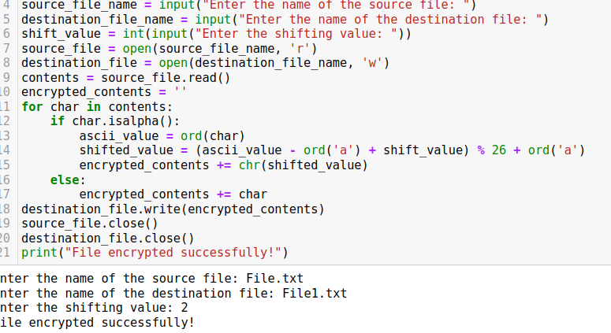of each character by a certain number), and write the encrypted text to a new file.

4.Write a program that searches for a specific word in a text file. The program should prompt the user to enter the word to search for, read the file, and display all the lines that contain the specified word.

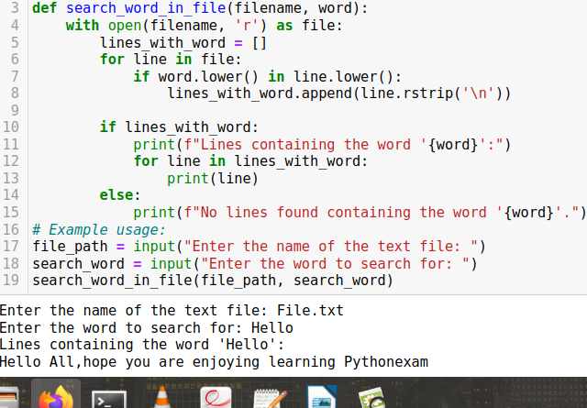5.Write a program that reads a text file and calculates various statistics, such as the number of lines, the number of words, and the average word length.

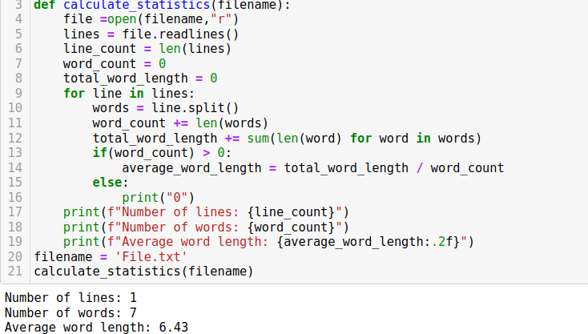

6.Write a program that appends a new line of text to an existing text file. The program should prompt the user to enter the text to be appended and then add it as a new line at the end of the file.

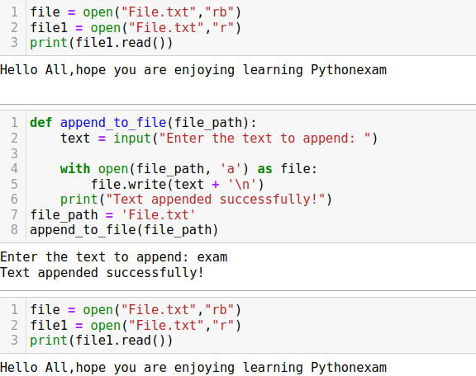

**Project:4:**

# Online Food Ordering System:

Create a program that simulates an online food ordering system. Users can browse restaurants, view menus, and place orders for delivery or pickup

### introduction:

* An online food ordering system allows your business to accept and manage orders placed online for delivery or takeaway.
* Customers browse a digital menu, either on an app or website and place and pay for their order online.
* Our online ordering system will help you transform your website into a money-making machine.
* No matter how much your business grows, you will always be able to take free unlimited orders with zero costs.
* Power your business with our free restaurant online ordering system & you’ll never have to worry about fees or commissions.

**Program:**

class Restaurant:

def __init__(self, name, cuisine):

self.name = name

self.cuisine = cuisine

self.menu = []

def add_item_to_menu(self, item):

self.menu.append(item)

class MenuItem:

menu = {

"pizza": 3.00,

"nachos": 4.50,

"popcorn": 6.00,

"fries": 2.50,

"chips": 1.00,

"pretzel": 5.00,

"soda": 3.00,

"lemonade": 4.25

}

def display_menu(self):

if not self.menu:

print("Menu is empty.")

return

print("---------MENU----------")

for key, value in self.menu.items():

print(f"{key:10}:${value:.2f}")

print("------------------------")

def get_user_order(self):

cart = []

while True:

food = input("Select an item (q to quit): ").lower()

if food == "q":

break

elif self.menu.get(food) is not None:

cart.append(food)

return cart

class Order:

def __init__(self, restaurant, items, delivery, address):

self.restaurant = restaurant

self.items = items

self.delivery = delivery

self.address = address

def calculate_total(self):

total = 0

for food in self.items:

total += MenuItem.menu.get(food)

return total

class OnlineFoodOrderingSystem:

def __init__(self):

self.restaurants = []

def add_restaurant(self, restaurant):

self.restaurants.append(restaurant)

def browse_restaurants(self):

print("Available Restaurants:")

for i, restaurant in enumerate(self.restaurants):

print(f"{i+1}. {restaurant.name}")

selection = int(input("Select a restaurant: "))

if 1 <= selection <= len(self.restaurants):

return self.restaurants[selection - 1]

else:

print("Invalid selection.")

return None

def place_order(self, restaurant, items, delivery):

if delivery:

address = input("Enter delivery address: ")

else:

address = ""

order = Order(restaurant, items, delivery, address)

total = order.calculate_total()

print("Order placed successfully!")

print(f"Restaurant: {restaurant.name}")

print("Items:")

for item in items:

print(f"- {item}: ${MenuItem.menu.get(item):.2f}")

print(f"Delivery: {'Yes' if delivery else 'No'}")

if delivery:

print(f"Address: {address}")

print(f"Total: ${total:.2f}")

# Creating restaurants and adding them to the system

system = OnlineFoodOrderingSystem()

restaurant1 = Restaurant("Restaurant A", "Italian")

restaurant1.add_item_to_menu(MenuItem())

system.add_restaurant(restaurant1)

restaurant2 = Restaurant("Restaurant B", "Chinese")

restaurant2.add_item_to_menu(MenuItem())

system.add_restaurant(restaurant2)

# Simulating user interaction

selected_restaurant = system.browse_restaurants()

if selected_restaurant is not None:

menu_item = MenuItem()

menu_item.display_menu() # Display menu only once

print()

selected_items = menu_item.get_user_order()

delivery = True if input("Do you want delivery? (yes/no): ").lower() == "yes" else False

system.place_order(selected_restaurant, selected_items, delivery)

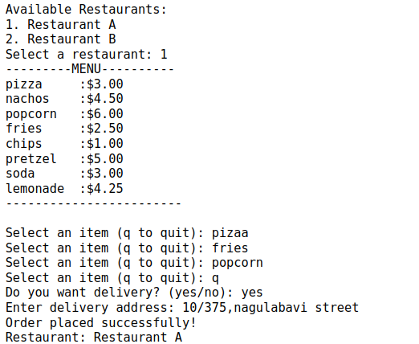

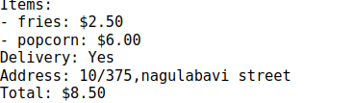

**Assignment-01**

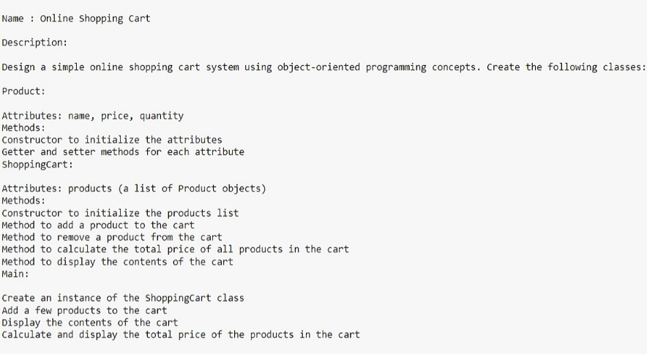

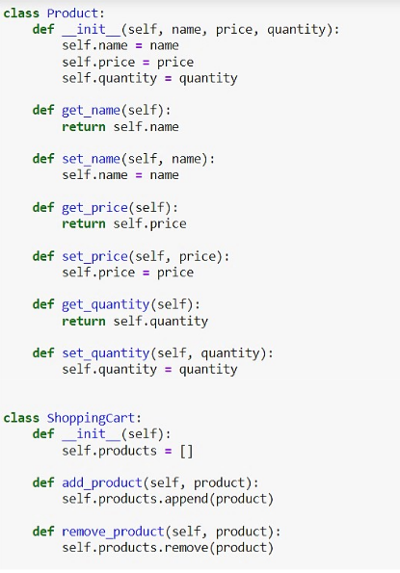

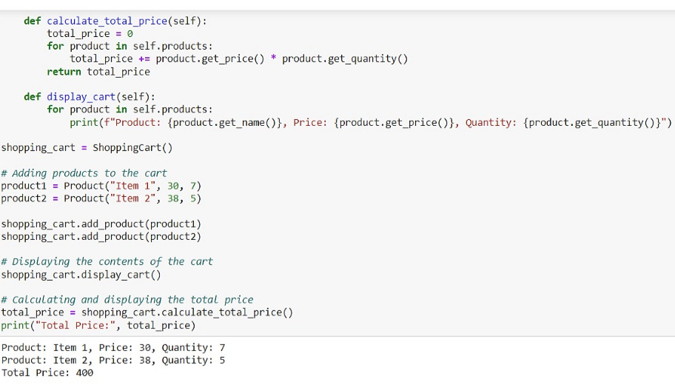

**Assignment-2**

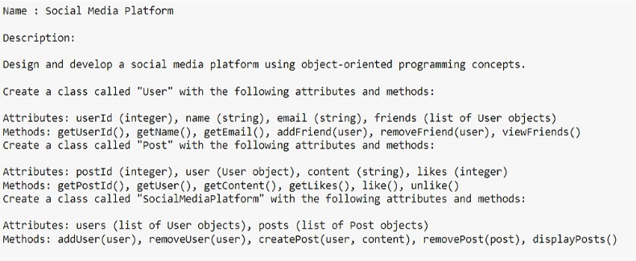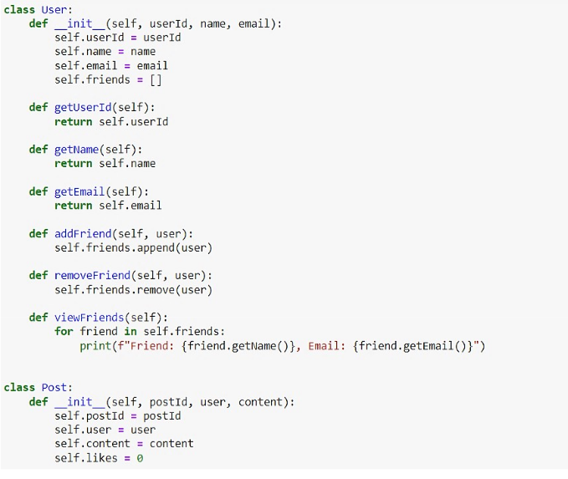

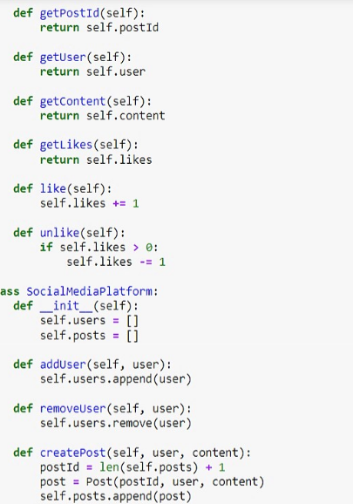

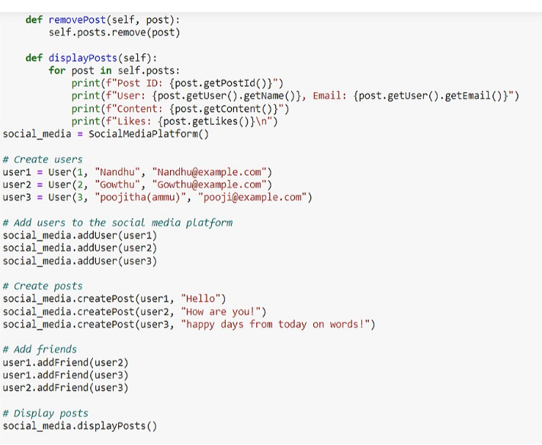

### 

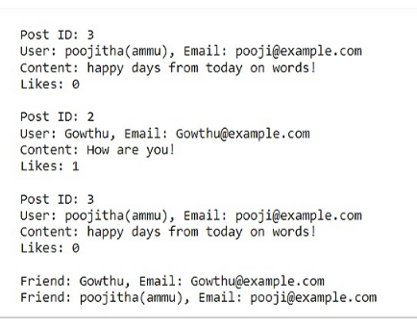

### **Assignment-3:**

Topics:

• Supervised Machine Learning

• Unsupervised Machine Learning

• Limitations of Supervised and Unsupervised Machine Learning

• Types of Supervised Machine Learning and Uses.

**MACHINE LEARNING**

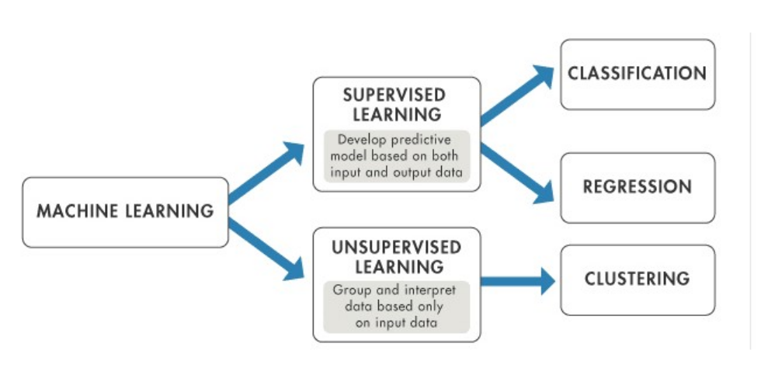**Supervised Machine Learning**

Supervised machine learning learns patterns and relationships between input and

output data. It contains a model that is able to predict with the help of a labeled

dataset. A labeled dataset is one where you already know the target answer.

It is defined by its use of labeled data. A labeled data is a dataset that contains a lot

of examples of Features and Target. Supervised learning uses algorithms that learn

the relationship of Features and Target from the dataset. This process is referred to

as Training or Fitting.

Example:suppose you are given a basket filled with different kinds of fruits. Now the

first step is to train the machine with all the different fruits one by one like this:

• If the shape of the object is rounded and has a depression at the top, is red in

color, then it will be labeled as –Apple.

• If the shape of the object is a long curving cylinder having Green-Yellow color,

then it will be labeled as –Banana.Unsupervised Machine Learning:

• It requirs unstructure data

• No need of target and explict algorithm

**Unsupervised learning** is the training of a machine using information that is neither classified nor labeled and allowing the algorithm to act on that nformation without guidance. Here the task of the machine is to group unsorted information according to similarities, patterns, and differences without any prior training of data.

Examples:suppose it is given an image having both dogs and cats which it has never

seen. the machine has no idea about the features of dogs and cats so we can’t

categorize it as ‘dogs and cats ‘. But it can categorize them according to their

similarities, patterns, and differences, i.e., we can easily categorize the picture into

two parts. The first may contain all pics having dogs in them and the second part may

contain all pics having cats in them.

**Limitations of Supervised and Unsupervised Machine Learning**

*In supervised learning*, the algorithm “learns” from the training dataset by iteratively

making predictions on the data and adjusting for the correct answer. While supervised

learning models tend to be more accurate than unsupervised learning models, they require upfront human intervention to label the data appropriately. For example, a supervised learning model can predict how long your commute will be based on the time of day, weather conditions and so on. But first, you’ll have to train it to know that rainy weather extends the driving time.

*Unsupervised learning models*, in contrast, work on their own to discover the inherent

structure of unlabeled data. Note that they still require some human intervention for

validating output variables. For example, an unsupervised learning model can identify that online shoppers often purchase groups of products at the same time. However, a data analyst would need to validate that it makes sense for a recommendation engine to group baby clothes with an order of diapers, applesauce and sippy cups.

Types of Supervised Machine Learning and Uses.

Supervised learning can be further divided into two types:

• Classification

• Regression

Classification : Classification is a type where algorithms learn from the data to predict an outcome or event in the future.Classification algorithms are used for predicting discrete outcomes, if the outcome can take two possible values such as True or False, Default or NoDefault, Yes or No, it is known as Binary Classification. When the outcome contains more than two possible values, it is known as Multiclass Classification. There are many machine learning algorithms that can be used for classification tasks.

Some of them are:

* Logistic Regression
* Decision Tree Classifier
* K Nearest Neighbor Classifier
* Random Forest Classifier
* Neural Networks

Regression :where algorithms learn from the data to predict continuous values such

as sales, salary, weight, or temperature. There are many machine learning algorithms

that can be used for regression tasks. Some of them are:

* Linear Regression
* Decision Tree Regressor
* K Nearest Neighbor Regressor
* Random Forest Regressor
* Neural Networks

**Project:5**

9 : Estimating Insurance Claim Amounts : Problem Statement: Estimating Insurance Claim Amounts Project Description: Develop a regression model to estimate the claim amounts for insurance policies based on customer profiles, policy details, and historical claim data. Domain: Insurance Dataset Link:<https://www.kaggle.com/competitions/allstate-claims-severity/data?select=train.csv>

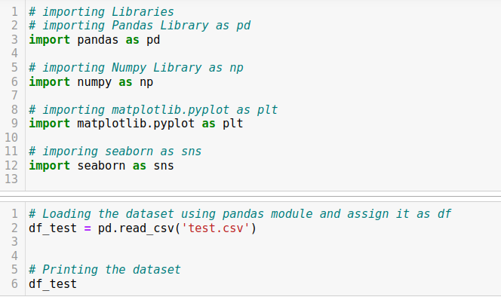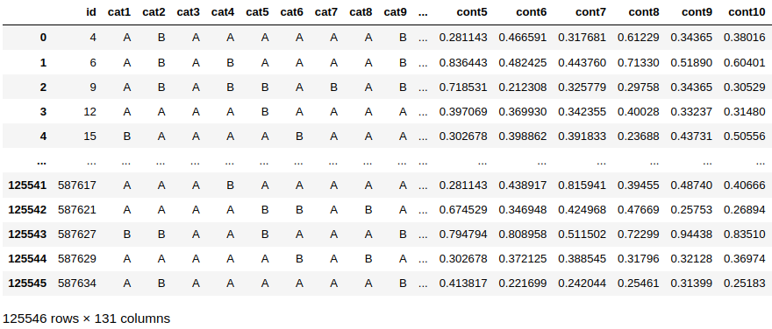

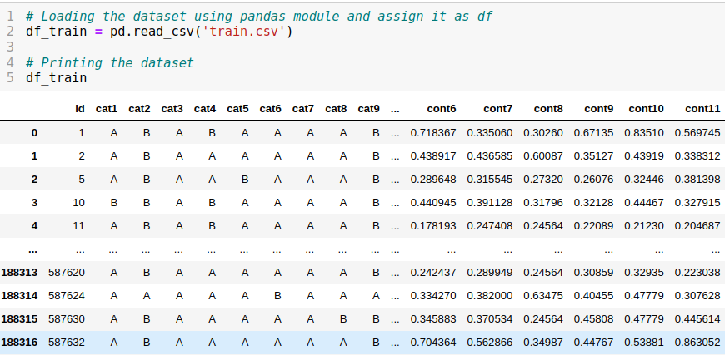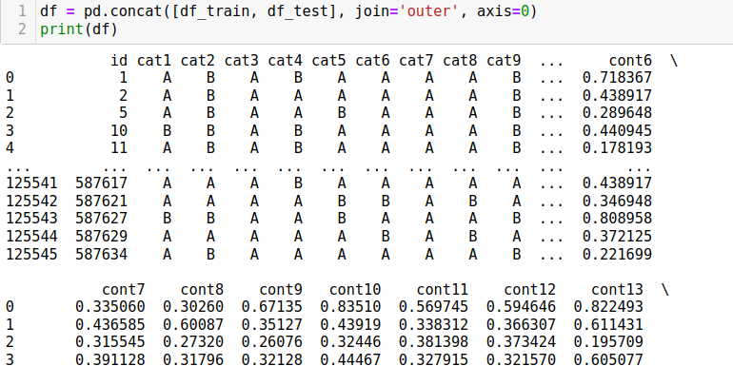

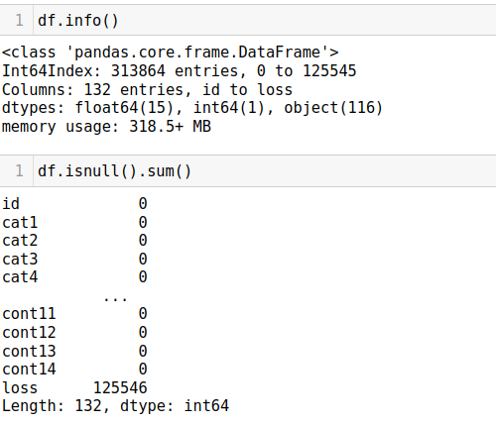

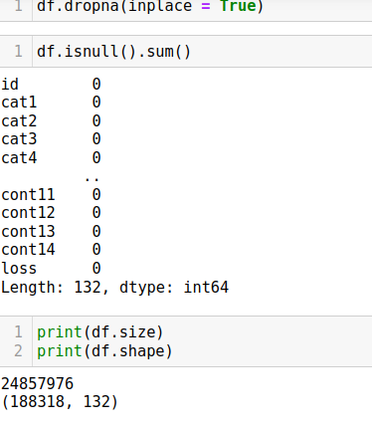

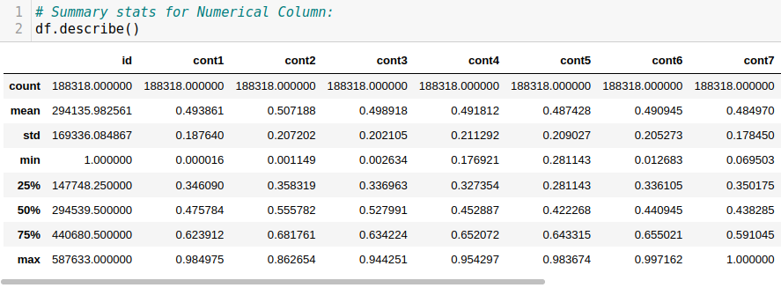

## Data Visuvalization

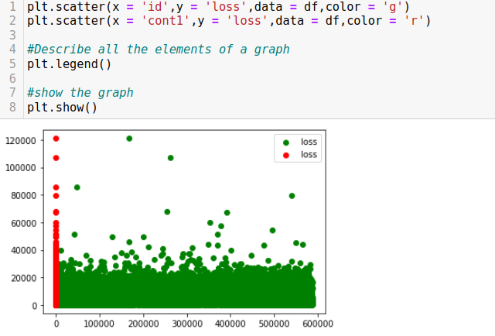

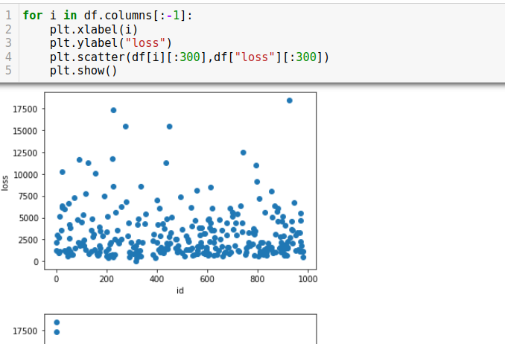

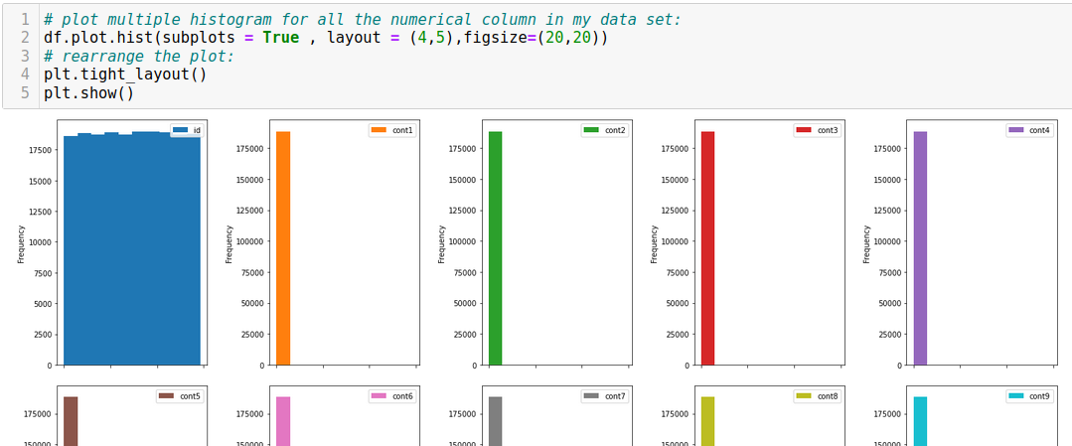

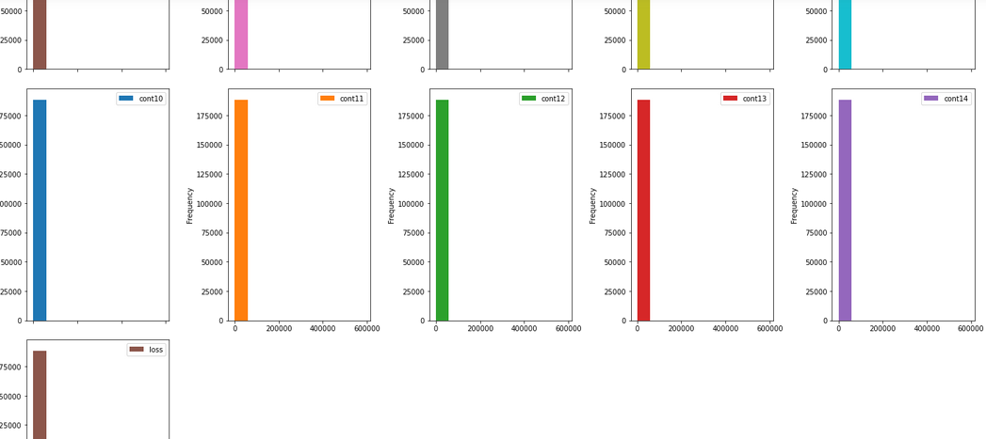

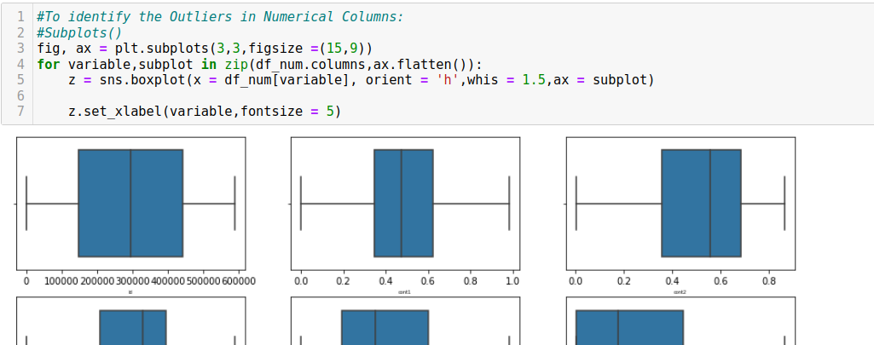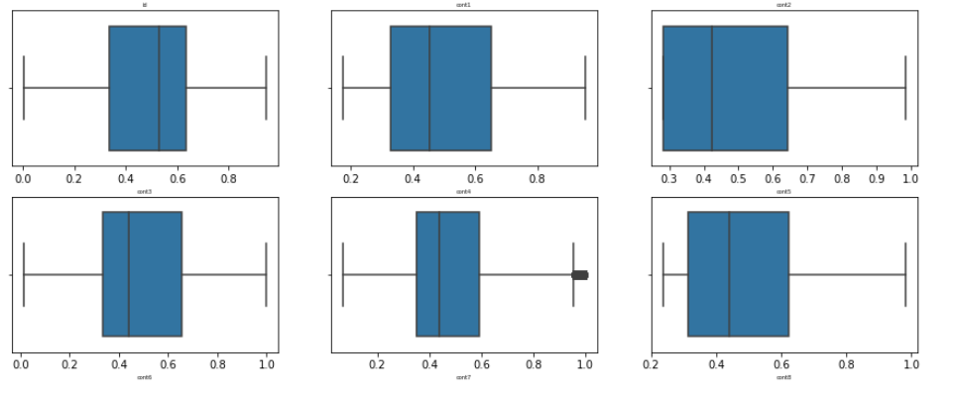

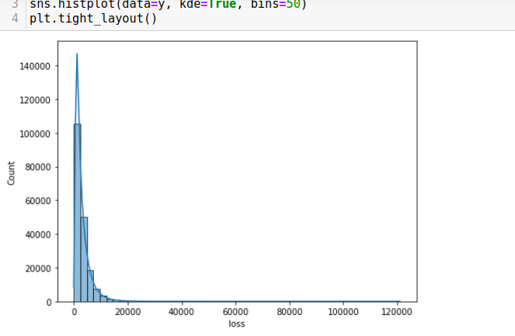

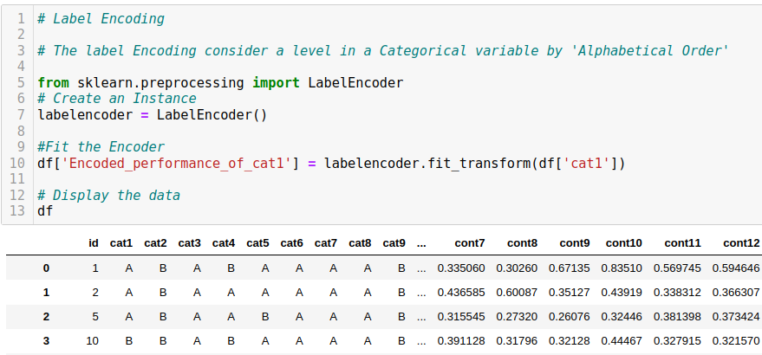

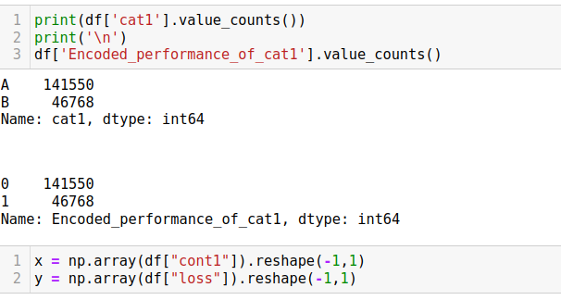

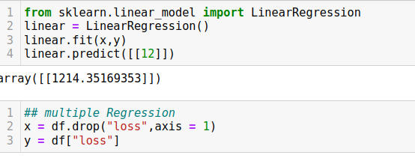

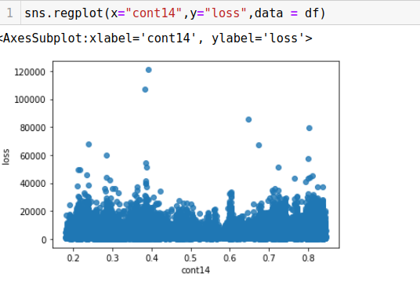

### 

### 

### 

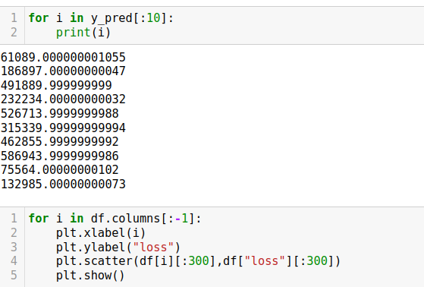

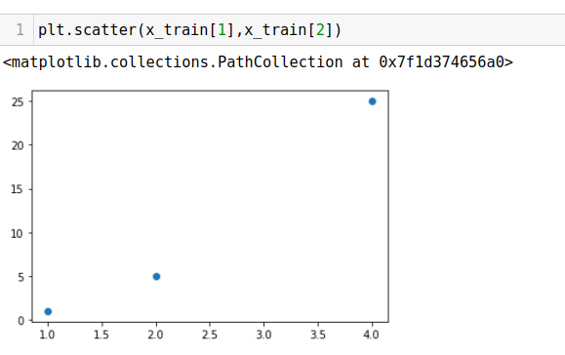

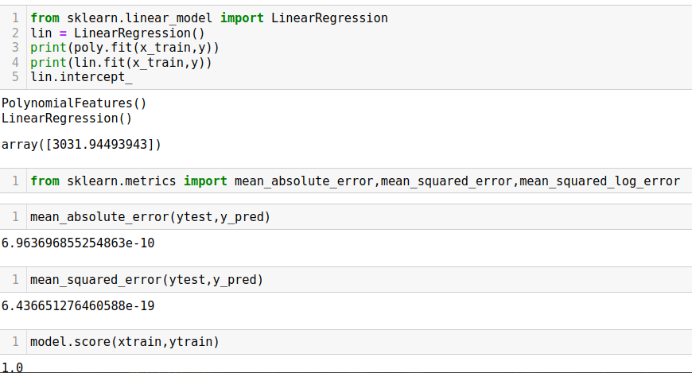

### Classification

### **Project 6:**

6 : Predict Bank Credit Risk : Project Title Predict Bank Credit Risk using South German Credit Data Domain Banking

Problem Statement: Normally, most of the bank's wealth is obtained from providing credit loans so that a marketing bank must be able to reduce the risk of non-performing credit loans. The risk of providing loans can be minimized by studying patterns from existing lending data. One technique that you can use to solve this problem is to use data mining techniques. Data mining makes it possible to find hidden information from large data sets by way of classification. The goal of this project, you have to build a model to predict whether the person, described by the attributes of the dataset, is a good (1) or a bad (0) credit risk

Dataset Link : <https://www.kaggle.com/competitions/south-german-credit-prediction/data>

Dataset Fields

The below list consists of a detailed breakdown of all the features in the Dataset. 'Kredit' is our target variable, the one whose value must be predicted. P.S. The feature names are in German to preserve the authenticity of the data. In the dataset, they can be replaced using the DataDescription.csv file and the Pandas library.

Id = Id of individual entries, for evaluation

laufkont = status

1 : no checking account

2 : … < 0 DM 3 : 0<= … < 200 DM 4 : … >= 200 DM / salary for at least 1 year

laufzeit = duration

moral = credit_history

0 : delay in paying off in the past

1 : critical account/other credits elsewhere

2 : no credits taken/all credits paid back duly

3 : existing credits paid back duly till now

4 : all credits at this bank paid back duly

verw = purpose

0 : others

1 : car (new)

2 : car (used)

3 : furniture/equipment

4 : radio/television

5 : domestic appliances

6 : repairs

7 : education

8 : vacation

9 : retraining

10 : business

hoehe = amount

sparkont = savings

1 : unknown/no savings account

2 : … < 100 DM 3 : 100 <= … < 500 DM 4 : 500 <= … < 1000 DM 5 : … >= 1000 DM

beszeit = employment_duration

1 : unemployed

2 : < 1 yr 3 : 1 <= … < 4 yrs 4 : 4 <= … < 7 yrs 5 : >= 7 yrs

rate = installment_rate

1 : >= 35

2 : 25 <= … < 35

3 : 20 <= … < 25

4 : < 20

famges = personal_status_sex

1 : male : divorced/separated

2 : female : non-single or male : single

3 : male : married/widowed

4 : female : single

buerge = other_debtors

1 : none

2 : co-applicant

3 : guarantor

wohnzeit = present_residence

1 : < 1 yr 2 : 1 <= … < 4 yrs 3 : 4 <= … < 7 yrs 4 : >= 7 yrs

verm = property

1 : unknown / no property

2 : car or other

3 : building soc. savings agr./life insurance

4 : real estate

alter = age

weitkred = other_installment_plans

1 : bank

2 : stores

3 : none

wohn = housing

1 : for free

2 : rent

3 : own

bishkred = number_credits

1 : 1

2 : 2-3

3 : 4-5

4 : >= 6

beruf = job

1 : unemployed/unskilled - non-resident

2 : unskilled - resident

3 : skilled employee/official

4 : manager/self-empl./highly qualif. employee

pers = people_liable

1 : 3 or more

2 : 0 to 2

telef = telephone

1 : no

2 : yes (under customer name)

gastarb = foreign_worker

1 : yes

2 : no

kredit (target column) = credit_risk

0 : bad

1 : good

### 

### 

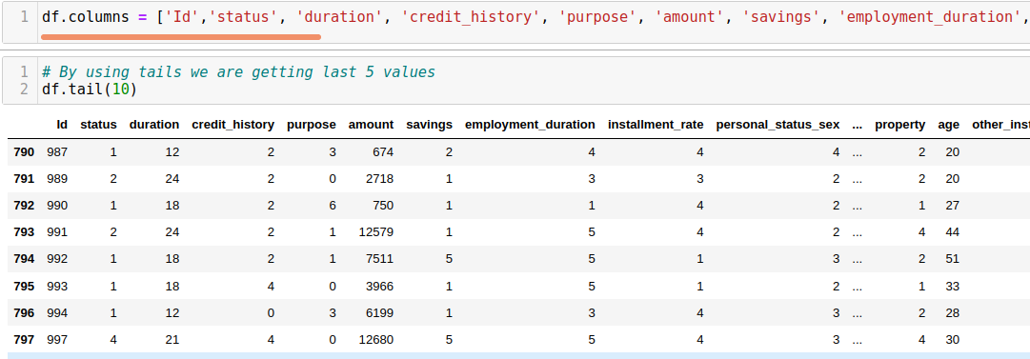

### 

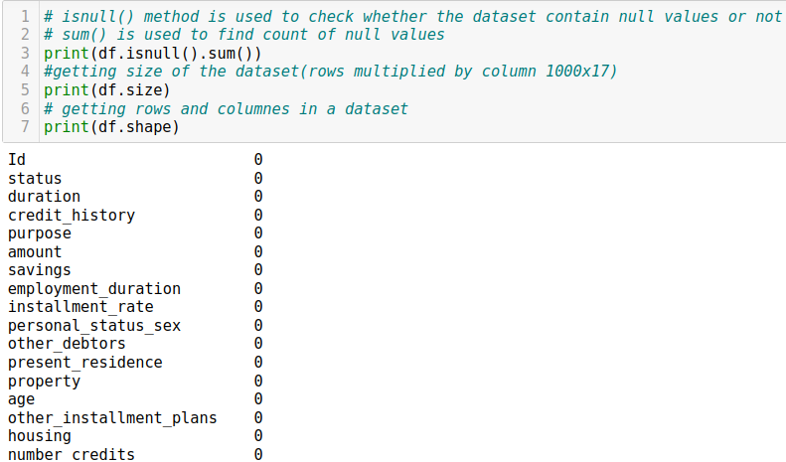

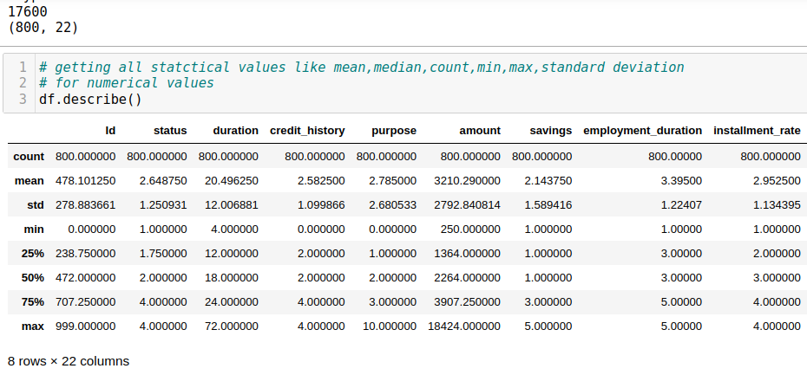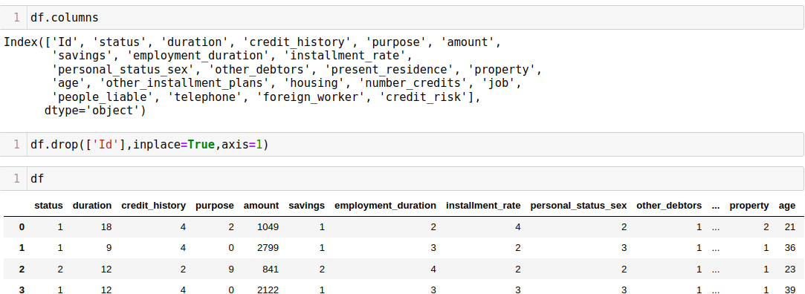

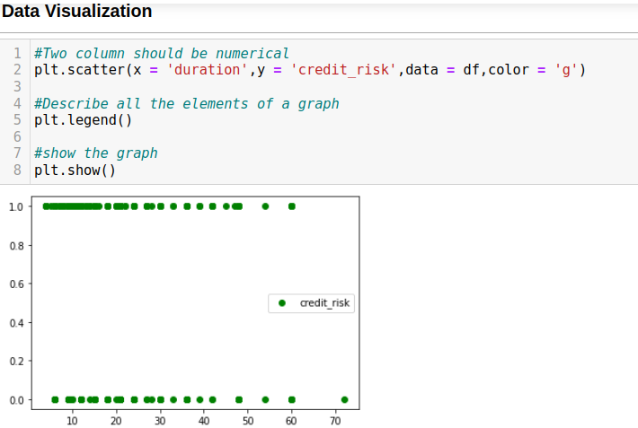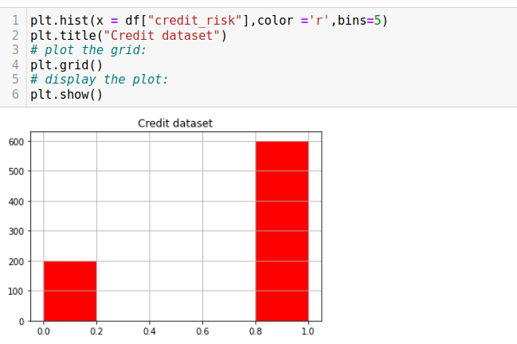

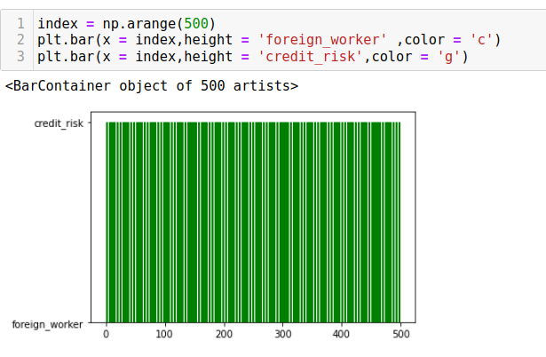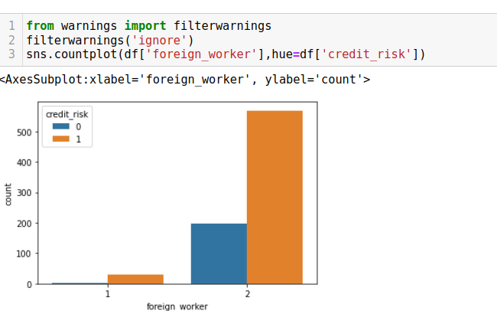

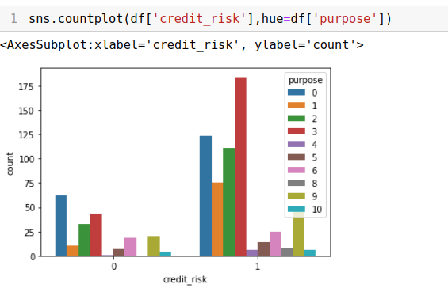

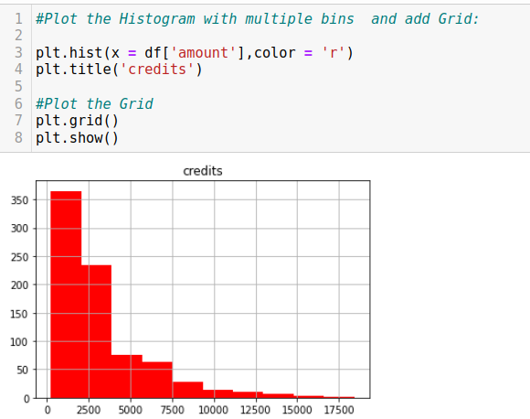

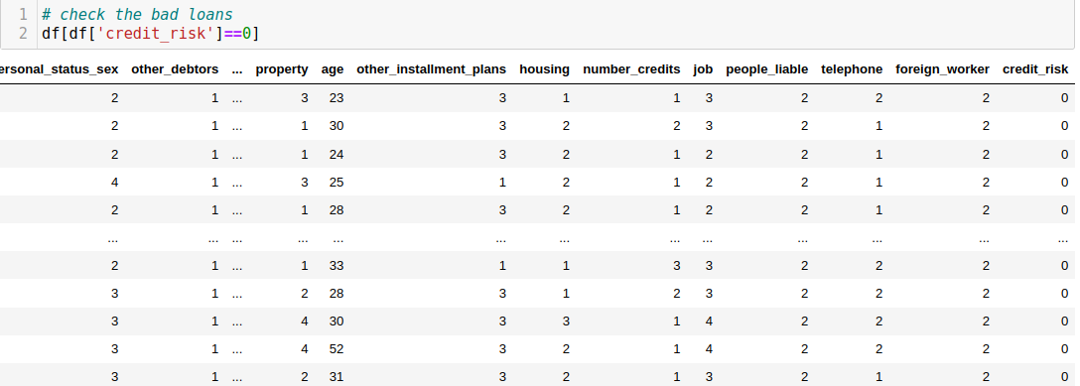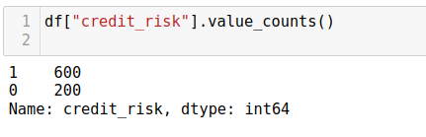

**DATA TRANSFORMATION**

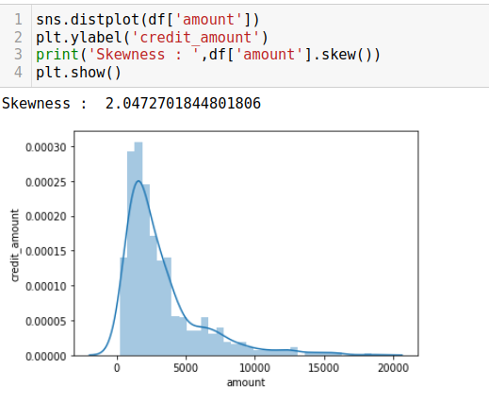

### 

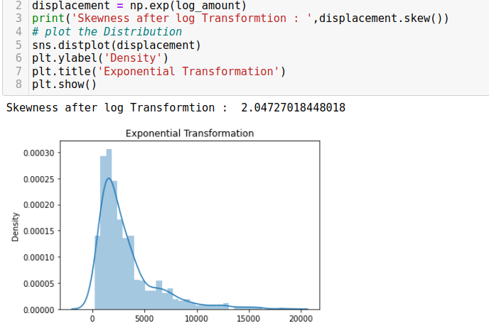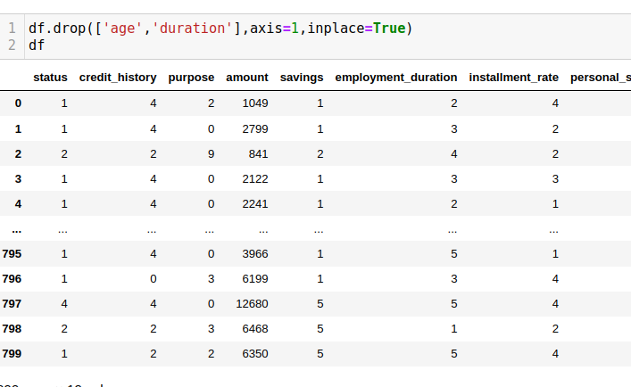

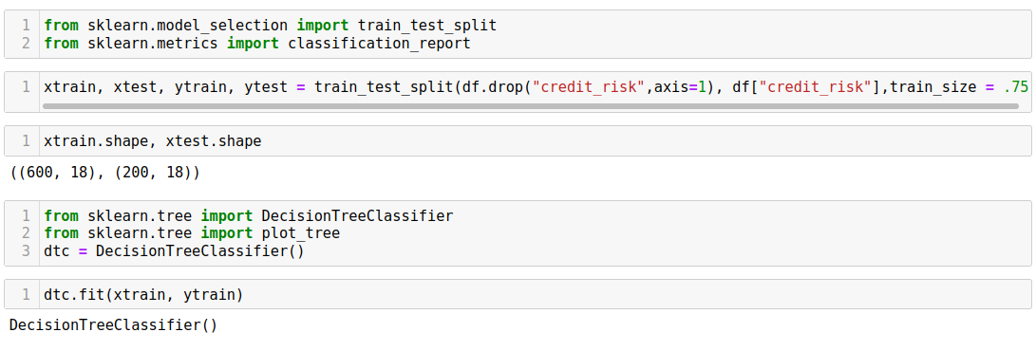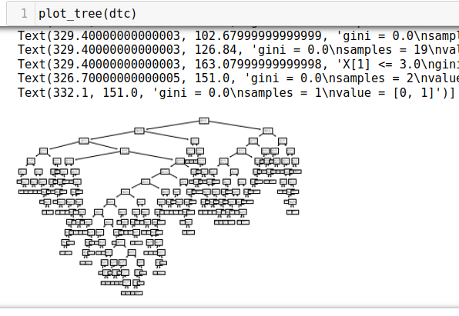

### 

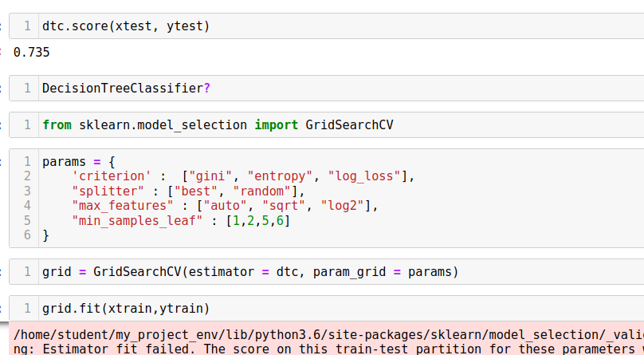

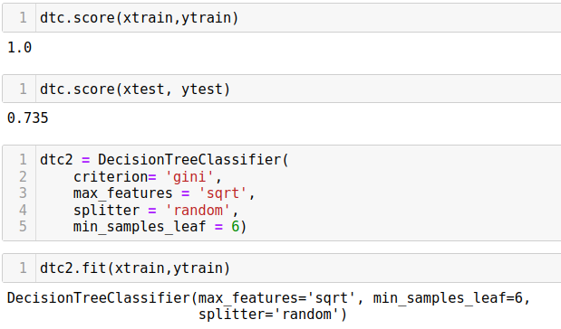

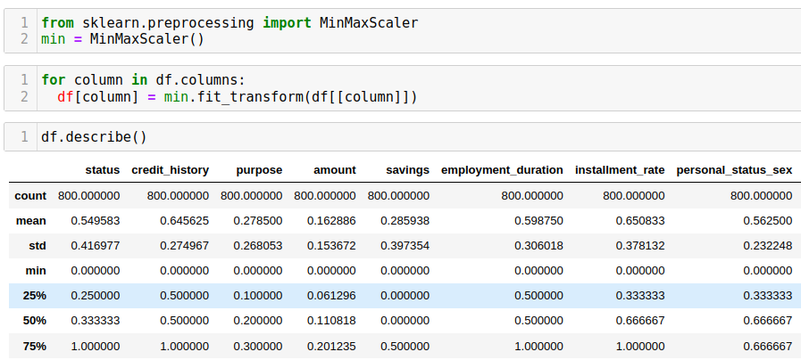

### 

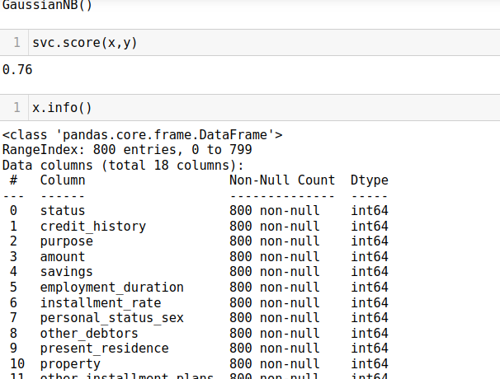

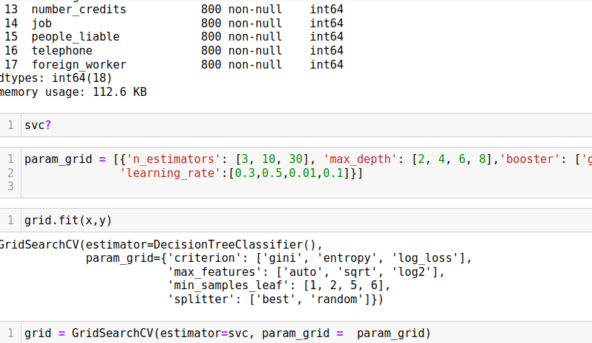

### 

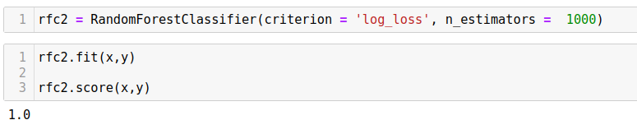

### Clustering

### **Project 6:**

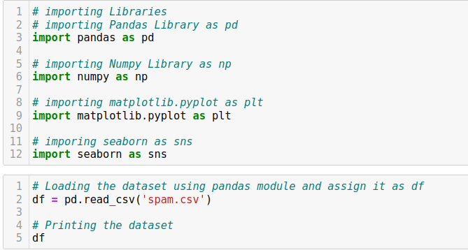Email Spam Detection : Email Spam Detection: Cluster email data to detect spam or malicious messages. Procedure: Apply K-means on email features like sender, subject, content, and attachments to group similar emails. Domain: Cybersecurity Dataset Link: <https://www.kaggle.com/code/mfaisalqureshi/email-spam-detection-98-accuracy/input?select=spam.csv>

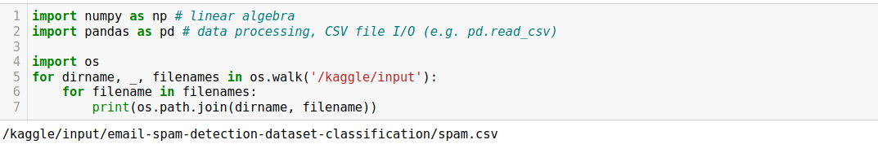

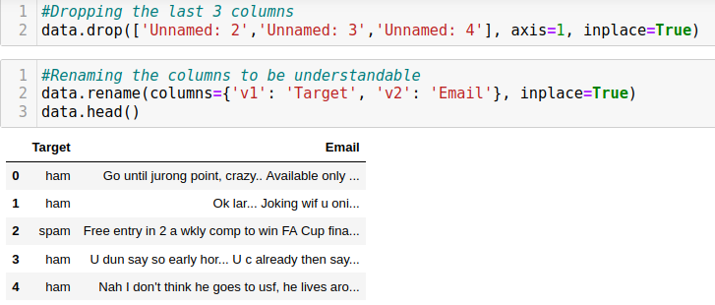

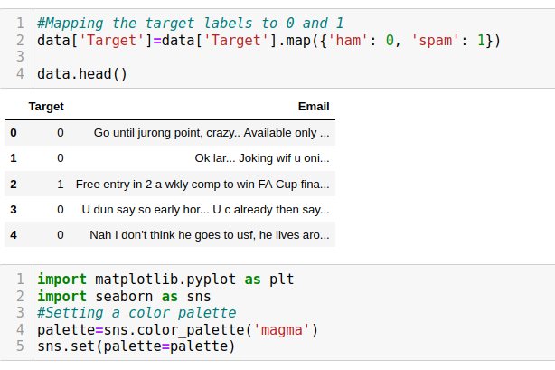

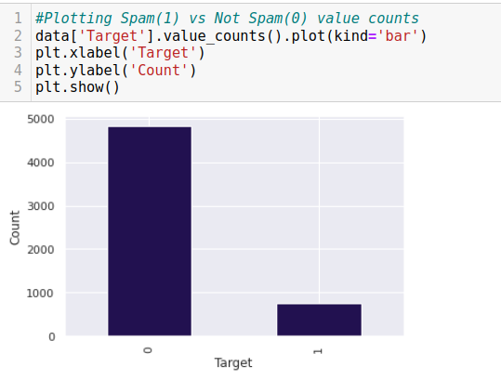

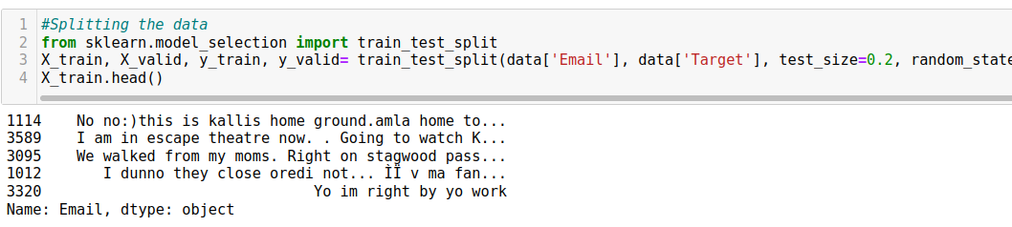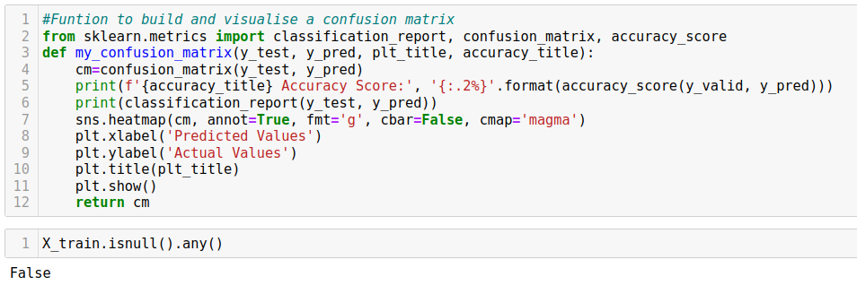

### 

### 

### 

### 

### 

### 

### 

### 4.STUDENT FEEDBACK

**I** am very thankful for giving me this opportunity to the SURE Trust. I enjoyed the course and learned a lot from it. The content is well organized and focused on both theory and practical situations. I particularly enjoyed the teaching style of trainer who have teach this course to us. Because, he teach this course in understanding manner. And I learned life skills, how to prepare resume from ‘LST’ Session. I loved it. And ‘EACH ONE PLANT ONE’ program inspires me a lot in SURE Trust. I really thankful to SURE Trust.

**5.UNIQUENESS OF THE CROUSE**

* Faculty is committed in delivering the course
* Concepts are learnt theoretically and practically
* Thought provoking assignments will be given
* Preparation of course report, which will help us to refer in the future
* Concentrate on each and every student in the course

**6.Concluding Remarks**

A lot of experience, knowledge and exposure that I have handy. All disclosures were awaken myself in a boost of self-confidence to face life more challenging now. Practical is a complement to the science or theory learned. I conclude that the SURE Trust training program has provided many benefits to students. I really proud to be a student of SURE Trust.